Gilford Parks and Recreation
Seeking Lifeguards for this Summer!

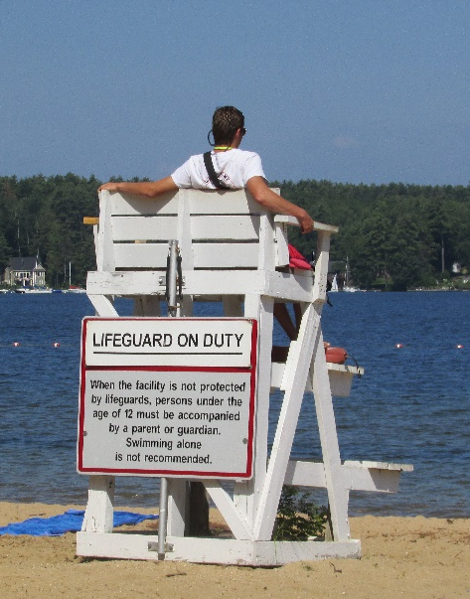
The Gilford Parks and Recreation Department is currently seeking Lifeguards for the 2022 summer season at the Gilford Town Beach. Pay range is $15.00/hr - $17.25/hr depending upon experience.

Applicants must be 16 years of age and possess a current American Red Cross Waterfront Lifeguard Certification (WSI preferred, but not mandatory) by the summer of 2022. The Parks and Recreation Department will help coordinate initial Lifeguard Certification and will reimburse employees for cost of certification!

Call the Gilford Parks and Recreation Dept. at
527-4722 for more information.
