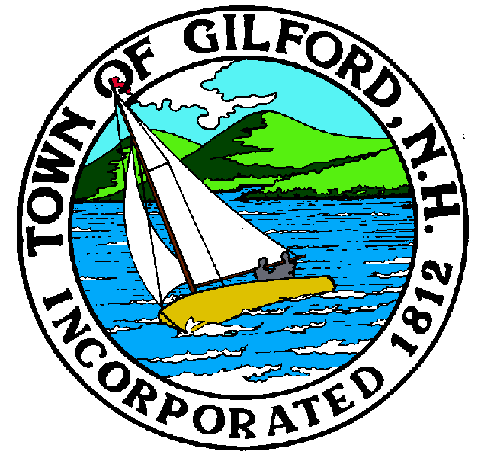
GILFORD CONSERVATION COMMISSION

TUESDAY

JANUARY 17, 2023

GILFORD TOWN HALL

47 CHERRY VALLEY ROAD

GILFORD, NH 03249
7:00 P.M.

You may attend the meeting in person at the Town Hall, or join the meeting remotely with a computer, tablet or smartphone by using the following link:
https://global.gotomeeting.com/join/859301829
You can also dial in using your phone.
United States: +1 (646) 749-3122
Access Code: 859-301-829
REMOTE PARTICIPATION IS PROVIDED AS A COURTESY. SHOULD THERE BE TECHNICAL DIFFICULTIES WITH THE TOWN’S SYSTEM, THE MEETING/HEARING WILL NOT BE ADJOURNED.

PLEDGE OF ALLEGIANCE

ATTENDANCE:
- Call Meeting to Order
- Establish a Quorum
- Approval of Agenda

PRESENTATIONS:

APPLICATIONS:
1. Wetland Permit Application, Standard Dredge and Fill, for Jeffrey R. Holland at 364 Edgewater Drive on Tax Map & Lot #218-029.000 for a single-story boat house.
2. Wetland Permit Application, Standard Dredge and Fill, for Town of Gilford at 47 Cherry Valley Road on Tax Map & Lot #266-054.000, to rehabilitate deteriorating south stone abutment of the Tannery Hill Covered Bridge over Gunstock Brook.
3. Wetland Permit Application, Standard Dredge and Fill, for Janice Farley at 164 Scenic Drive on Tax Map & Lot #252-007.000, to remove breakwater docking system and existing finger dock, dredge 45 cubic yards of fill, and construct 4 slip docking system protected by 35 foot breakwater, install 3 boat hoists, 3 seasonal canopies, and 3 ice clusters.

NON-PUBLIC: (If Needed) Non-public Session Per RSA 91-A:3 II (d) Consideration of the acquisition, sale, or lease of real or personal property which, if discussed in public, would likely benefit a party or parties whose interests are adverse to those of the general community.

OTHER BUSINESS:
- Conservation Easement for Ramblin Vewe
- Site Review
- Other

CORRESPONDENCE / WORKSHOPS:

MINUTES:

ADJOURNMENT:

