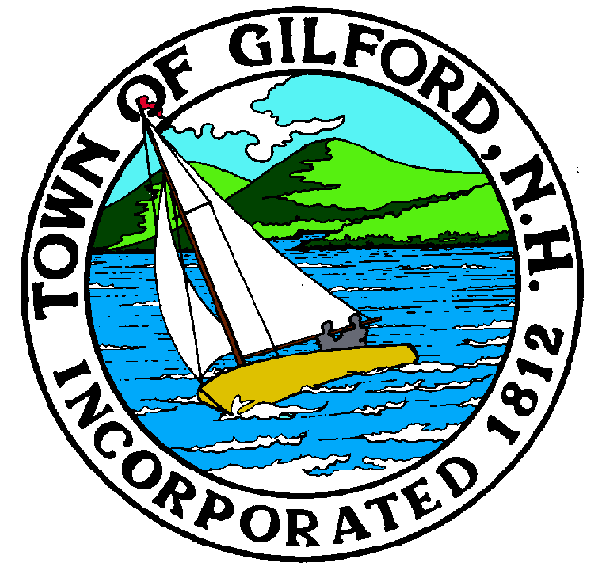

GILFORD CONSERVATION COMMISSION

TUESDAY

JANUARY 4, 2022

GILFORD TOWN HALL

47 CHERRY VALLEY ROAD

GILFORD, NH 03249
7:00 P.M.

PLEDGE OF ALLEGIANCE

ATTENDANCE:
a) Call Meeting to Order
b) Establish a Quorum
c) Approval of Agenda

PRESENTATIONS:

APPLICATIONS:

- Standard Dredge and Fill, Wetlands Permit Application for Carol A. Decola Family Trust at 14 Broadview Terrace on Tax Map & Lot #221-009.000. Project: Impact 365 sq. ft. to remove a granite and wood boat ramp and install a 365 sq. ft. perched beach with 6’ wide access steps to the lake. Install a seasonal 30’ x 14’ canopy supported by an aluminum frame over an existing permanent dock slip.

- Shoreland Permit Application for Laflamme Family Rev. Trust, Duke & Malinda E. Laflamme, TTEES at 39 Lockes Island on Tax Map & Lot #243-036.000. Project: Remove tree-damaged house and rebuild within the same general footprint.

NON-PUBLIC:
(If Needed) Non-public Session Per RSA 91-A:3 II (d) Consideration of the acquisition, sale, or lease of real or personal property which, if discussed in public, would likely benefit a party or parties whose interests are adverse to those of the general community.

OTHER BUSINESS:
- Weeks Parcel - parking plan
- Weeks Parcel - tree report
- NRI
- Other

CORRESPONDENCE / WORKSHOPS:

MINUTES:

ADJOURNMENT:

