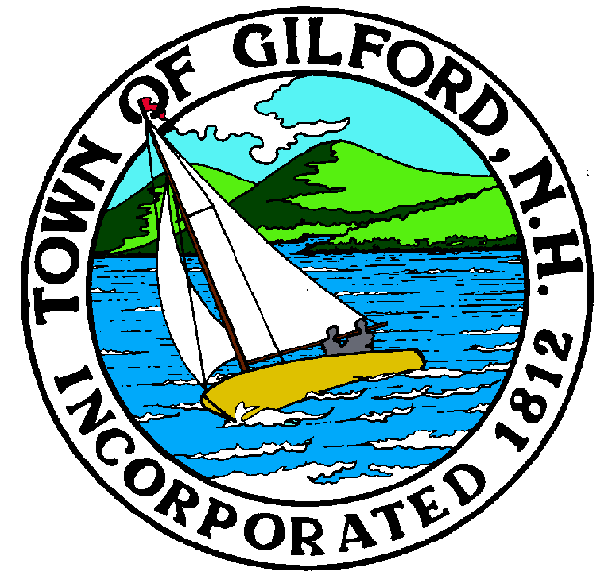

GILFORD CONSERVATION COMMISSION

TUESDAY

OCTOBER 4, 2022

GILFORD TOWN HALL

47 CHERRY VALLEY ROAD

GILFORD, NH 03249
7:00 P.M.

You may attend the meeting in person at the Town Hall, or join the meeting remotely with a computer, tablet or smartphone by using the following link:
https://global.gotomeeting.com/join/859301829
You can also dial in using your phone.
United States: +1 (646) 749-3122
Access Code: 859-301-829
REMOTE PARTICIPATION IS PROVIDED AS A COURTESY. SHOULD THERE BE TECHNICAL DIFFICULTIES WITH THE TOWN’S SYSTEM, THE MEETING/HEARING WILL NOT BE ADJOURNED.

PLEDGE OF ALLEGIANCE

ATTENDANCE:
a) Call Meeting to Order b) Establish a Quorum c) Approval of Agenda

APPLICATIONS:

Wetlands Permit Application for Fay’s Boat Yard, Inc. 71 Varney Point Road, Tax Map & Lot # 223-498.000. To extend and relocate existing docks to accommodate larger boats and enhance safety. Deferred to DES.

Report out on only
- Standard Dredge & Fill, Wetlands Permit Application for 44 Varney Point Road Left
- Wetlands Permit-By-Notification for 55 Welch Island
- Standard Dredge & Fill, Wetlands Permit Application for 3 Camp Island

NON-PUBLIC: (If Needed) Non-public Session Per RSA 91-A:3 II (d) Consideration of the acquisition, sale, or lease of real or personal property which, if discussed in public, would likely benefit a party or parties whose interests are adverse to those of the general community.

OTHER BUSINESS:
- Weeks Parcel - update
- 2022 Budget
- 2023 Budget preparation
- Smith Cove invoice
- Annual Conservation Easement Monitoring – Tim Nolan
6. Other

CORRESPONDENCE / WORKSHOPS:
- NHACC Annual Meeting
- Saving Special Places

MINUTES: August 16, 2022 & September 6, 2022

ADJOURNMENT:

