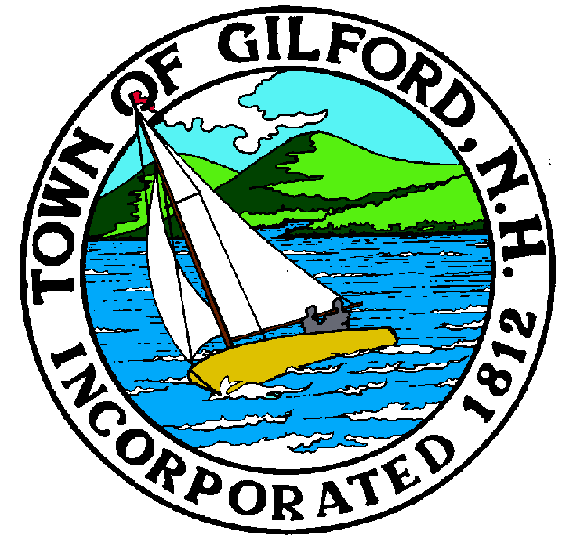

GILFORD CONSERVATION COMMISSION

TUESDAY

NOVEMBER 2, 2021

GILFORD TOWN HALL

47 CHERRY VALLEY ROAD

GILFORD, NH 03249
7:00 P.M.

You may attend the meeting in person at the Town Hall, or join the meeting remotely with a computer, tablet or smartphone by using the following link:
https://global.gotomeeting.com/join/859301829
You can also dial in using your phone.
United States: +1 (646) 749-3122
Access Code: 859-301-829
REMOTE PARTICIPATION IS PROVIDED AS A COURTESY. SHOULD THERE BE TECHNICAL DIFFICULTIES WITH THE TOWN’S SYSTEM, THE MEETING/HEARING WILL NOT BE ADJOURNED.

PLEDGE OF ALLEGIANCE

ATTENDANCE:
a) Call Meeting to Order
b) Establish a Quorum
c) Approval of Agenda

PRESENTATIONS:
1. Non-public Session Per RSA 91- A:3 II (d). Consideration of the acquisition, sale, or lease of real or personal property which, if discussed in public, would likely benefit a party or parties whose interests are adverse to those of the general community.

2. Jones & Beach Engineers, Inc. – 1429 Lake Shore Road.

APPLICATIONS:

NON-PUBLIC:
(If Needed) Non-public Session Per RSA 91-A:3 II (d) Consideration of the acquisition, sale, or lease of real or personal property which, if discussed in public, would likely benefit a party or parties whose interests are adverse to those of the general community.

OTHER BUSINESS:
- Invoices
- Weeks Trail Update
- Other

CORRESPONDENCE / WORKSHOPS:

MINUTES:

ADJOURNMENT:

