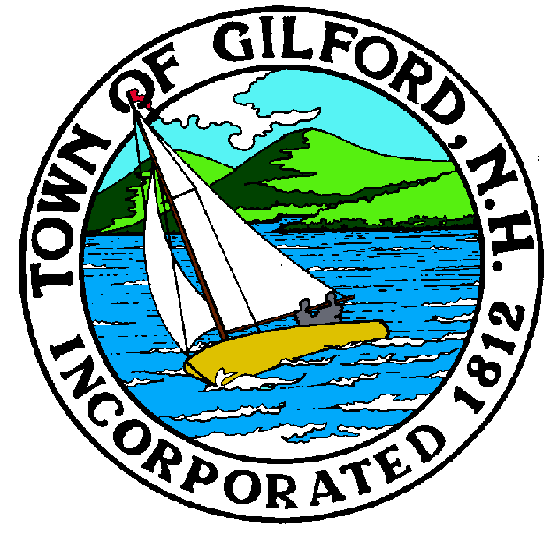

GILFORD CONSERVATION COMMISSION

TUESDAY

DECEMBER 7, 2021

GILFORD TOWN HALL

47 CHERRY VALLEY ROAD

GILFORD, NH 03249
7:00 P.M.

PLEDGE OF ALLEGIANCE

ATTENDANCE:
a) Call Meeting to Order
b) Establish a Quorum
c) Approval of Agenda

PRESENTATIONS:

APPLICATIONS:

- NHDES Wetlands Permit Application – Bret & Anuradha Connor, 24 Broadview Terrace, Tax Map & Lot # 221-021.000

NON-PUBLIC:
(If Needed) Non-public Session Per RSA 91-A:3 II (d) Consideration of the acquisition, sale, or lease of real or personal property which, if discussed in public, would likely benefit a party or parties whose interests are adverse to those of the general community.

OTHER BUSINESS:
- Weeks Parcel – access crossing easement
- Other

CORRESPONDENCE / WORKSHOPS:

MINUTES:

ADJOURNMENT:

