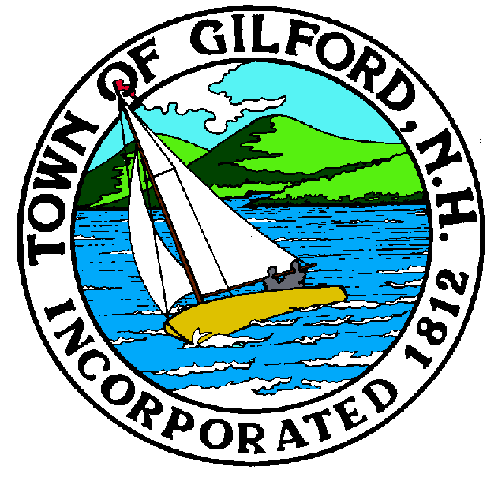
GILFORD CONSERVATION COMMISSION

MONDAY

FEBRUARY 13, 2023

GILFORD TOWN HALL

LUNCH ROOM – BOTTOM FLOOR

47 CHERRY VALLEY ROAD

GILFORD, NH 03249
7:00 P.M.

The Gilford Conservation Commission will hold a special meeting at 7:00 PM on Monday, February 13, 2023 in the Lunch Room of the Gilford Town Hall at 47 Cherry Valley Road in Gilford, NH, to consider the following matters:

PLEDGE OF ALLEGIANCE

ATTENDANCE:
- Call Meeting to Order
- Establish a Quorum
- Approval of Agenda

PRESENTATIONS:

APPLICATIONS:

1. Wetland Permit Application, Standard Dredge and Fill, for Jeffrey R. Holland at 364 Edgewater Drive on Tax Map & Lot #218-029.000 for a single-story boat house. Application was tabled from the January 17, 2023 meeting.

NON-PUBLIC: (If Needed) Non-public Session Per RSA 91-A:3 II (d) Consideration of the acquisition, sale, or lease of real or personal property which, if discussed in public, would likely benefit a party or parties whose interests are adverse to those of the general community.

OTHER BUSINESS:
- Confirm joint Gilford/Laconia conservation meeting for March 7, 2023 at Gilford
- Other

CORRESPONDENCE / WORKSHOPS:

MINUTES: December 20, 2022

ADJOURNMENT:

S:\DPLU\Conservation\Con Com Agendas\2023\2-13-2023 CC Special Meeting Agenda.docx

