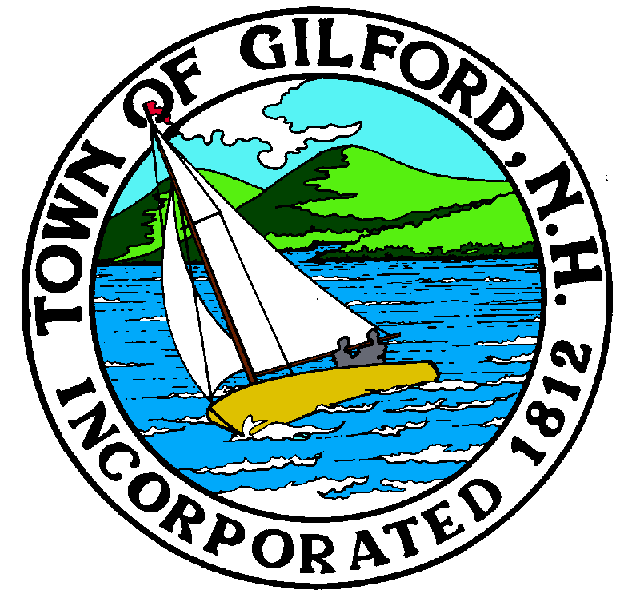
GILFORD CONSERVATION COMMISSION

TUESDAY

FEBRUARY 20, 2024

GILFORD TOWN HALL

47 CHERRY VALLEY ROAD

GILFORD, NH 03249
7:00 P.M.

You may attend the meeting in person at the Town Hall, or join the meeting remotely with a computer, tablet or smartphone by using the following link:
https://global.gotomeeting.com/join/859301829
REMOTE PARTICIPATION IS PROVIDED AS A COURTESY. SHOULD THERE BE TECHNICAL DIFFICULTIES WITH THE TOWN’S SYSTEM, THE MEETING/HEARING WILL NOT BE ADJOURNED.

PLEDGE OF ALLEGIANCE:

ATTENDANCE:
- Call Meeting to Order
- Establish a Quorum
- Approval of Agenda

APPLICATIONS:
- Wetlands Permit by Notification for Doug Surprenant/BLC and Dan Hubley at 132 Scenic Dr. Total Impact of 3,266 sf. Riparian planting on both banks of Reed Brook (between two culverts) for about 100 linear feet. Additional soil and stone (with mortised equipment) to stabilize the areas adjacent to brook & allow larger plantings to take root. Additional care will be given the brook itself, to trap sediment form entering Lake Winnipesaukee. All plantings will be native. Tabled from the February 6, 2024, meeting.

- Wetlands Permit Application – Standard Dredge and Fill application for Governor’s Island Club at 500 Edgewater Drive to improve the revetment system to prevent further erosion of the shoreline. Tabled from the February 6, 2024, meeting.

- Wetlands Permit Application - Standard Dredge and Fill for Daniel Patrick Gabriel at 12 Lockes Island. The project proposal is to reconfigure an existing 805 sf “L” Shape grandfathered breakwater and 302 sf dock. Proposing o provide a 655 sf breakwater with a 6’ x 28 cantilevered pier to a 4’wx3’ connecting pilings supported walkway toa 3’ x x28’ piling dock in a “U” shaped configuration accessed by a 3’ wood framed stepped access over the bank (42sf) to provide mor functional boatslips/safe docking.

NON-PUBLIC: (If Needed) Non-public Session Per RSA 91-A:3 II (d) Consideration of the acquisition, sale, or lease of real or personal property which, if discussed in public, would likely benefit a party or parties whose interests are adverse to those of the general community.

OTHER BUSINESS:
- Robert Brown – Black Brook Study
- NHDES and the letter regarding 47 Cherry Valley Rd, tabled from the December 4, 2023 meeting.
- Campbell Easement Letter
- Other.

CORRESPONDENCE / WORKSHOPS:

MINUTES: February 6, 2024

ADJOURNMENT:

