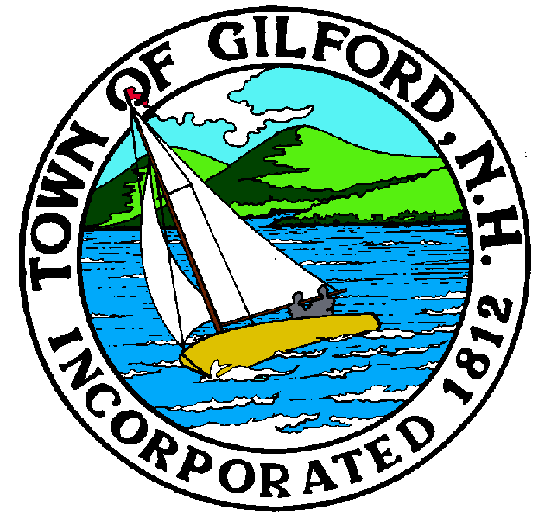

GILFORD CONSERVATION COMMISSION

TUESDAY

MARCH 16, 2021

GILFORD TOWN HALL

47 CHERRY VALLEY RD

GILFORD, NH 03249
7:00 p.m.

* Due to COVID-19, anyone may join the meeting via GoToMeeting.com:
https://global.gotomeeting.com/join/214068437
You can also dial in using your phone.
United States: +1 (646) 749-3122
Access Code: 214-068-437
PLEDGE OF ALLEGIANCE

ATTENDANCE:
a) Call Meeting to Order
b) Establish a quorum
c) Approval of Agenda

PRESENTATIONS:

APPLICATIONS:
1. Standard Dredge & Fill, Wetlands Permit Application for Douglas & Susan Flint at 135 Dockham Shore Rd.
2. Standard Dredge & Fill, Wetlands Permit Application for Puneet & Geeti Gangal at 193 Dockham Shore Rd.
3. Standard Dredge & Fill, Wetlands Permit Application for Thomas & Tara Benson at 56 Terrace Hill Rd.

NON-PUBLIC:
(If Needed) Non-public Session Per RSA 91-A:3 II (d) Consideration of the acquisition, sale, or lease of real or personal property which, if discussed in public, would likely benefit a party or parties whose interests are adverse to those of the general community.

OTHER BUSINESS:
- Johnson wind damage (if needed)
- Tim Nolin Weeks Forestry proposal
- End of year budget report Lee
- Site Review
- Other

CORRESPONDENCE / WORKSHOPS: Saving Special Places on April 9th & 10th

MINUTES:

ADJOURNMENT:

