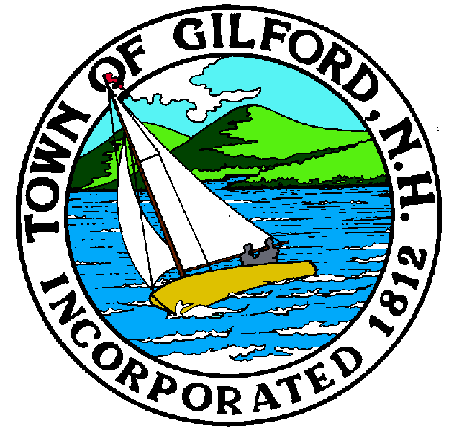
GILFORD CONSERVATION COMMISSION

TUESDAY

MARCH 19, 2024

GILFORD TOWN HALL

47 CHERRY VALLEY ROAD

GILFORD, NH 03249
7:00 P.M.

You may attend the meeting in person at the Town Hall, or join the meeting remotely with a computer, tablet or smartphone by using the following link:
https://global.gotomeeting.com/join/859301829
REMOTE PARTICIPATION IS PROVIDED AS A COURTESY. SHOULD THERE BE TECHNICAL DIFFICULTIES WITH THE TOWN’S SYSTEM, THE MEETING/HEARING WILL NOT BE ADJOURNED.

PLEDGE OF ALLEGIANCE:

ATTENDANCE:

- Call Meeting to Order
- Establish a Quorum
- Approval of Agenda

APPLICATIONS:

- Wetlands Permit by Notification for Doug Surprenant/BLC and Dan Hubley at 132 Scenic Dr. Tabled from the February 20, 2024, meeting.

- Standard Dredge & Fill, Wetlands Permit Application for Lake Winnipesaukee Sailing Association Inc., Guy Nickerson, Representative at 25 Davis Road on Tax Map & Lot # 223-530.000. The proposal is to remove the existing 7x50’ permanent docking structure, to be replaced by a new seasonal docking structure with an associated concrete anchor block in a different location on the same frontage. The new dock structure is to be 6x200’ long.

- Standard Dredge & Fill, Wetlands Permit Application for the Town of Gilford at Swain Road over Jewett Brook on Tax Map 209. The project is to remove the existing 65’ long culvert and replace it with a 50’ long, 10’ wide x 8’ tall concrete box culvert. Stream bed simulation will be installed in the culvert matching the existing brook channel elevations.

NON-PUBLIC: (If Needed) Non-public Session Per RSA 91-A:3 II (d) Consideration of the acquisition, sale, or lease of real or personal property which, if discussed in public, would likely benefit a party or parties whose interests are averse to those of the general community.

OTHER BUSINESS:
- Black Brook Study
- Alva Wilson Property
- Dock Road – Marine Patrol
- Campbell Easement Letter
- Other.

CORRESPONDENCE / WORKSHOPS:

MINUTES: February 20, 2024

ADJOURNMENT:

