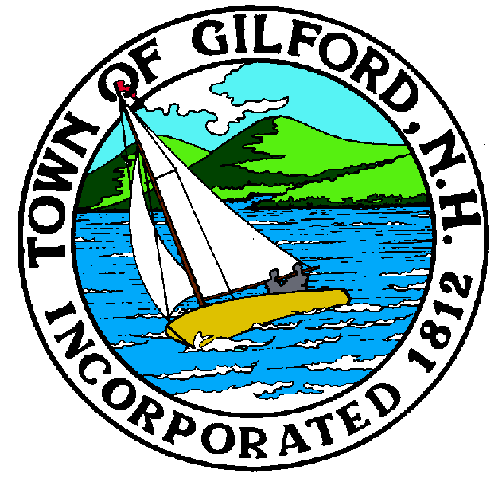
JOINT MEETING OF THE

GILFORD CONSERVATION COMMISSION

&

LACONIA CONSERVATION COMMISSION

TUESDAY

MARCH 7, 2023

GILFORD TOWN HALL

47 CHERRY VALLEY ROAD

GILFORD, NH 03249
7:00 P.M.

You may attend the meeting in person at the Town Hall, or join the meeting remotely with a computer, tablet or smartphone by using the following link:
https://global.gotomeeting.com/join/859301829
You can also dial in using your phone.
United States: +1 (646) 749-3122
Access Code: 859-301-829
REMOTE PARTICIPATION IS PROVIDED AS A COURTESY. SHOULD THERE BE TECHNICAL DIFFICULTIES WITH THE TOWN’S SYSTEM, THE MEETING/HEARING WILL NOT BE ADJOURNED.

PLEDGE OF ALLEGIANCE

ATTENDANCE:
- Call Meeting to Order
- Establish a Quorum
- Approval of Agenda

JOINT MEETING
There will be a Joint Meeting held between Gilford and Laconia Conservation Commissions. The purpose of this meeting is to discuss the possibility of doing some work along Black Brook in the two towns in regards to the geomorphological study done several years ago by both conservation commissions:
https://www.laconianh.gov/DocumentCenter/View/2382/Black-Brook-Geomorph-Assessment-and-Plan-20160707-PDF

ADJOURN JOINT MEETING

NON-PUBLIC: Non-public Session Per RSA 91-A:3 II (d) Consideration of the acquisition, sale, or lease of real or personal property which, if discussed in public, would likely benefit a party or parties whose interests are adverse to those of the general community.

ADJOURNMENT:

