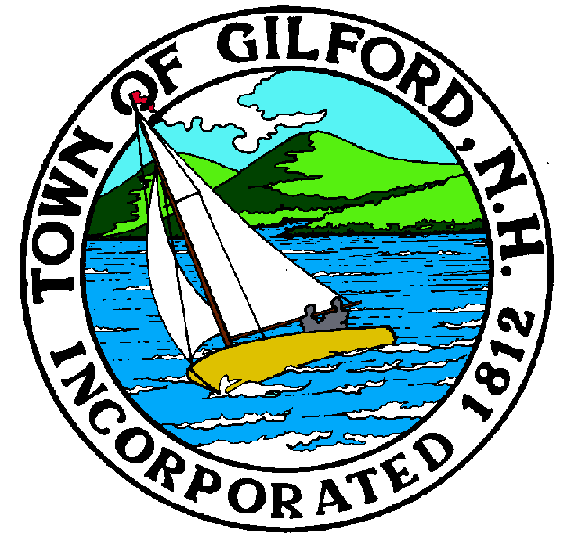
GILFORD CONSERVATION COMMISSION

TUESDAY

APRIL 18, 2023

GILFORD TOWN HALL

47 CHERRY VALLEY ROAD

GILFORD, NH 03249
7:00 P.M.

You may attend the meeting in person at the Town Hall, or join the meeting remotely with a computer, tablet or smartphone by using the following link:
https://global.gotomeeting.com/join/859301829
You can also dial in using your phone.
United States: +1 (646) 749-3122
Access Code: 859-301-829
REMOTE PARTICIPATION IS PROVIDED AS A COURTESY. SHOULD THERE BE TECHNICAL DIFFICULTIES WITH THE TOWN’S SYSTEM, THE MEETING/HEARING WILL NOT BE ADJOURNED.

PLEDGE OF ALLEGIANCE

ATTENDANCE:
- Call Meeting to Order
- Establish a Quorum
- Approval of Agenda

APPLICATIONS:
1. Wetland Permit Application, Standard Dredge and Fill, for the Paddocks, Stone Brook Hills, LLC at
166 Glidden Road on Tax Map & Lot #271-008.001. To subdivide the subject parcel into 5 separate single family lots, intermittent stream, & driveway crossing, and road crossings for a total 10,664 sq. ft. impact.

2. Wetland Permit Application, Standard Dredge and Fill, for Fair View Condominiums, at 218 Scenic Drive on Tax Map & Lot #252-013.000. To remove a permanent 6’ x 60’ piling dock & 2 ice cluster, install two seasonal 6’ x 40’ lift out docks. Install access stairs. Install 4 seasonal boat lifts.

3. Wetland Permit Application, Standard Dredge and Fill, for Anuradha Connor & Brett Russell at 24 Broadview Terrace on Tax Map & Lot #221-021.000. To reconfigure a non-conforming breakwater and dock reducing the existing dockage to one boat slip, install a 14’ x 30’ seasonal canvas canopy and permanent boat lift adjacent to remaining b/w & dockage. Install a 6’ x 35’ permanent piling dock in the location of removed crib dock to support two boat lifts, this include 2 ice cluster piles & fender piling and install 2 seasonal PWC lifts.

NON-PUBLIC: (If Needed) Non-public Session Per RSA 91-A:3 II (d) Consideration of the acquisition, sale, or lease of real or personal property which, if discussed in public, would likely benefit a party or parties whose interests are adverse to those of the general community.

OTHER BUSINESS:
- Any action needed following non-public
- Other

CORRESPONDENCE / WORKSHOPS:

MINUTES:

ADJOURNMENT:

