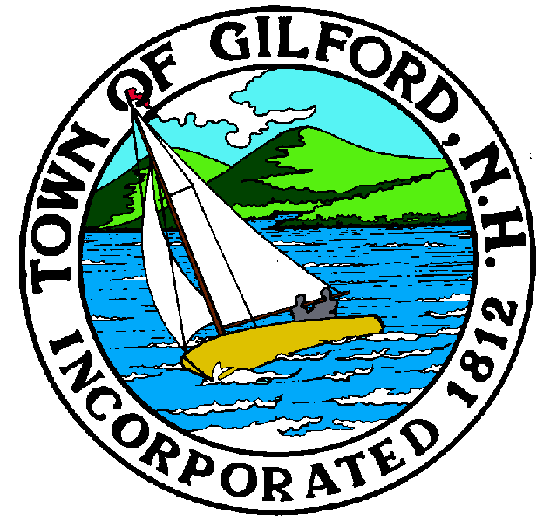
GILFORD CONSERVATION COMMISSION

TUESDAY

April 2, 2024

GILFORD TOWN HALL

47 CHERRY VALLEY ROAD

GILFORD, NH 03249
7:00 P.M.

You may attend the meeting in person at the Town Hall, or join the meeting remotely with a computer, tablet or smartphone by using the following link:
https://global.gotomeeting.com/join/859301829
REMOTE PARTICIPATION IS PROVIDED AS A COURTESY. SHOULD THERE BE TECHNICAL DIFFICULTIES WITH THE TOWN’S SYSTEM, THE MEETING/HEARING WILL NOT BE ADJOURNED.

PLEDGE OF ALLEGIANCE:

ATTENDANCE:

- Call Meeting to Order
- Establish a Quorum
- Approval of Agenda

PRESENTATIONS:

- Patricia Tarpey, President, Lake Winnipesaukee Association

- Black Brook Study update: Lisa Morin, Belknap County Conservation District and the Laconia Conservation Commission

APPLICATIONS:
- Wetlands Permit by Notification for Doug Surprenant/BLC and Dan Hubley at 132 Scenic Dr. Tabled from the February 20, 2024, meeting.

- Wetlands Permit Application, Dredge and Fill for Robert & Elizabeth Lancaster at 46 Dinsmore Point Rd., to repair and extend the existing breakwater and associated dockage, elevate the wall along the lakeside of the existing perched beach, replenish sand on the existing perched beach, construct a stand-alone piling supported dock with accessor pilings, a seasonal canopy and watercraft lifts.

NON-PUBLIC: (If Needed) Non-public Session Per RSA 91-A:3 II (d) Consideration of the acquisition, sale, or lease of real or personal property which, if discussed in public, would likely benefit a party or parties whose interests are averse to those of the general community.

OTHER BUSINESS:
- Site Study Review – Robert Brown
- Alva Wilson Property
- Campbell Easement Letter
- Other.

CORRESPONDENCE / WORKSHOPS:

MINUTES: March 19, 2024

ADJOURNMENT:

