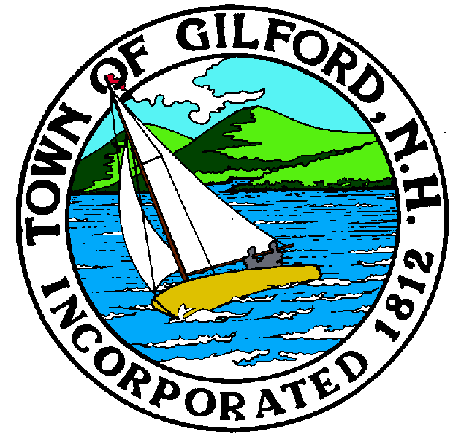

GILFORD CONSERVATION COMMISSION

TUESDAY

APRIL 20, 2021

GILFORD TOWN HALL

47 CHERRY VALLEY RD

GILFORD, NH 03249
7:00 p.m.

* Due to COVID-19, anyone may join the meeting via GoToMeeting.com:
https://www.gotomeet.me/meetingroom69/conservation-commissioni
You can also dial in using your phone.
United States: +1 (872) 240-3311
Access Code: 145-434-925

PLEDGE OF ALLEGIANCE

ATTENDANCE:
a) Call Meeting to Order
b) Establish a quorum
c) Approval of Agenda

PRESENTATIONS:

APPLICATIONS:

- Standard Dredge & Fill, Wetlands Permit Application for Gail A. Wildstein Irrevocable Trust at 112 Varney Point Road Left. Deferred from the April 6, 2021 meeting.
- Standard Dredge & Fill, Wetlands Permit Application for 118 NH 2015 Trust at 118 Varney Point Road Left. deferred from the April 6, 2021 meeting.

NON-PUBLIC:
(If Needed) Non-public Session Per RSA 91-A:3 II (d) Consideration of the acquisition, sale, or lease of real or personal property which, if discussed in public, would likely benefit a party or parties whose interests are adverse to those of the general community.

OTHER BUSINESS:

- Week’s Field
- Site Review
- Other

CORRESPONDENCE / WORKSHOPS:

MINUTES:

ADJOURNMENT:

Z:\Conservation\Con Com Agendas\2021\4-20-2021 CC Meeting Agenda.docx

