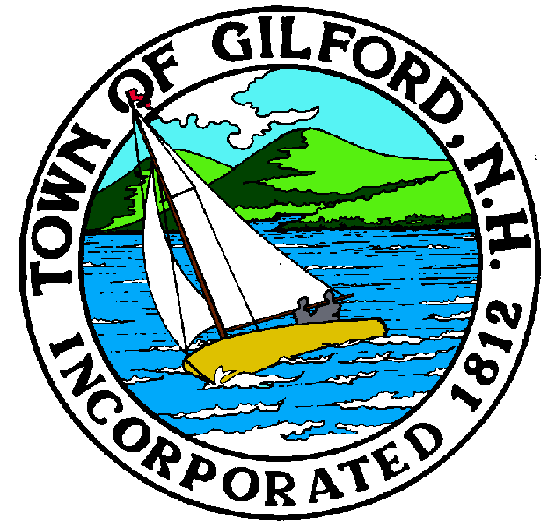

GILFORD CONSERVATION COMMISSION

TUESDAY

APRIL 5, 2022

GILFORD TOWN HALL

47 CHERRY VALLEY ROAD

GILFORD, NH 03249
7:00 P.M.

You may attend the meeting in person at the Town Hall, or join the meeting remotely with a computer, tablet or smartphone by using the following link:
https://global.gotomeeting.com/join/859301829
You can also dial in using your phone.
United States: +1 (646) 749-3122
Access Code: 859-301-829
REMOTE PARTICIPATION IS PROVIDED AS A COURTESY. SHOULD THERE BE TECHNICAL DIFFICULTIES WITH THE TOWN’S SYSTEM, THE MEETING/HEARING WILL NOT BE ADJOURNED.

PLEDGE OF ALLEGIANCE

ATTENDANCE:
a) Call Meeting to Order
b) Establish a Quorum
c) Approval of Agenda

PRESENTATIONS:

Erik Poulin, Jones & Beach Engineers, Inc., J & T Real Estate, 1477 Lakeshore Road, Tax Map & Lot #’s 213-000.021 & 015.

APPLICATIONS:

1. Dockham Shore Estates Association – 295 Dockham Shore Road, Tax, Map & Lot #216-008.000, Standard Dredge & Fill Wetlands application to replace two retaining walls and a boat launch.

2. Sharon & Robert Stewart – 61 Garden Hill Drive, Tax ,Map & Lot #208-033.016, Standard Dredge and Fill Wetlands application to install a driveway crossing culvert across roadside drainage ditch.

3. Edgewater Legacy, LLC – 224 Edgewater Drive, Tax, Map & Lot #218-003.000, Standard Dredge and Fill Wetlands application to permanently remove a u-shaped dock, and walkway and repair/replace wooden access stairs & concrete landing. Install a y-shaped breakwater dock & install two 14’ x 30’ seasonal canopies supported by two permanent boatlifts. Install a single seasonal boatlift and two seasonal PWC lifts in the northern-most boatslip. Also proposing a “hybrid” design of a breakwater in order to greatly reduced environmental impact.

4. Angsana, LLC – 87 Harris Shore Road, Tax, Map & Lot #223-396.000, Standard Dredge and Fill Wetlands Application to replace a failed wall to prevent further erosion.

5. Gervais – 48 Belknap Point Road, Tax, Map & Lot #242-206.000, Standard Dredge ad Fill Wetlands Permit Application to repair existing piling supported dock “in-kind”, add additional pilings for support of a seasonal canopy & an after the fact approval for a seasonal watercraft lift.

6. Marine Patrol Dock Replacement, Amendment to NHDES Wetlands permit #2021-01624.

NON-PUBLIC:
(If Needed) Non-public Session Per RSA 91-A:3 II (d) Consideration of the acquisition, sale, or lease of real or personal property which, if discussed in public, would likely benefit a party or parties whose interests are adverse to those of the general community.

OTHER BUSINESS:

- John & Eileen Weeks Parcel – appreciation event
- Use of Town Owned lands
- Other

CORRESPONDENCE / WORKSHOPS:

MINUTES:

ADJOURNMENT:

