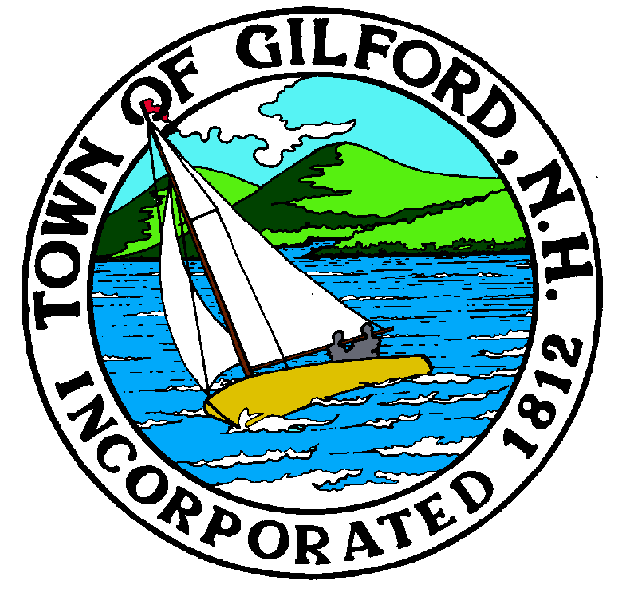

GILFORD CONSERVATION COMMISSION

TUESDAY

APRIL 6, 2021

GILFORD TOWN HALL

47 CHERRY VALLEY RD

GILFORD, NH 03249
7:00 p.m.

* Due to COVID-19, anyone may join the meeting via GoToMeeting.com:
https://www.gotomeet.me/meetingroom69/gilford-conservation-commission
You can also dial in using your phone.
United States: +1 (408) 650-3123
Access Code: 136-371-757

PLEDGE OF ALLEGIANCE

ATTENDANCE:
a) Call Meeting to Order
b) Establish a quorum
c) Approval of Agenda

PRESENTATIONS:

APPLICATIONS:
1. Standard Dredge & Fill, Wetlands Permit Application for Robert Smith Rev Trust at 211 Dockham Shore Road.
2. Standard Dredge & Fill, Wetlands Permit Application for Matthew Benson at 64 Belknap Point Road.
3. Standard Dredge & Fill, Wetlands Permit Application for Gail A. Wildstein Irrevocable Trust at 112 Varney Point Road Left.
4. Standard Dredge & Fill, Wetlands Permit Application for 118 NH 2015 Trust at 118 Varney Point Road Left.
5. Standard Dredge & Fill, Wetlands Permit Application for Lake Shore Park Association at 2600 Lake Shore Road.

NON-PUBLIC:
(If Needed) Non-public Session Per RSA 91-A:3 II (d) Consideration of the acquisition, sale, or lease of real or personal property which, if discussed in public, would likely benefit a party or parties whose interests are adverse to those of the general community.

OTHER BUSINESS:
- Tim Nolin – Annual Monitoring Proposal
- Other

CORRESPONDENCE / WORKSHOPS:

MINUTES:

ADJOURNMENT:

