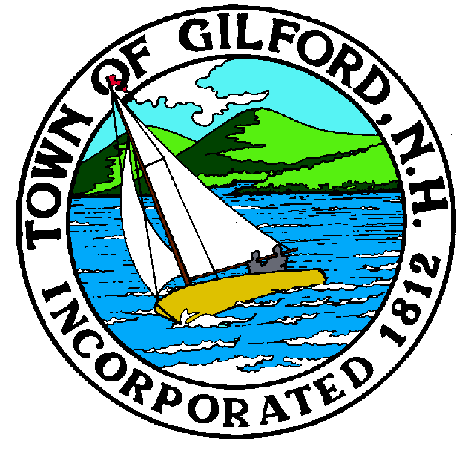

GILFORD CONSERVATION COMMISSION

TUESDAY

JUNE 1, 2021

GILFORD TOWN HALL

47 CHERRY VALLEY RD

GILFORD, NH 03249
7:00 p.m.

Please join my meeting from your computer, tablet or smartphone.
https://global.gotomeeting.com/join/859301829
You can also dial in using your phone.
United States: +1 (646) 749-3122
Access Code: 859-301-829
New to GoToMeeting? Get the app now and be ready when your first meeting starts: https://global.gotomeeting.com/install/859301829

PLEDGE OF ALLEGIANCE

ATTENDANCE:
a) Call Meeting to Order
b) Establish a quorum
c) Approval of Agenda

PRESENTATIONS:

APPLICATIONS:
- Standard Dredge & Fill, Wetlands Permit Application for NH Dept. of Administrative Services, Marine Patrol Headquarters at 31 Dock Road for dredge, re-build and extension of floating docks. Agent to be present.
- Standard Dredge & Fill, Wetlands Permit Application for 17 Lockes Island on Tax Map & Lot # 243-014.000 to add a seasonal dock protected from winds, add a new permeable water access patio at the lookout point by the pinnacle of the property and to reconstruct an old cottage and deck that are in disrepair.

NON-PUBLIC:
(If Needed) Non-public Session Per RSA 91-A:3 II (d) Consideration of the acquisition, sale, or lease of real or personal property which, if discussed in public, would likely benefit a party or parties whose interests are adverse to those of the general community.

OTHER BUSINESS:
- Week’s Field Site Visit Report – Doug Hill
- Update on Ellacoya wall rebuild – information only
- Site Review
- Other

CORRESPONDENCE / WORKSHOPS:

MINUTES:

ADJOURNMENT:

Z:\Conservation\Con Com Agendas\2021\6-1-2021 CC Meeting Agenda.docx

