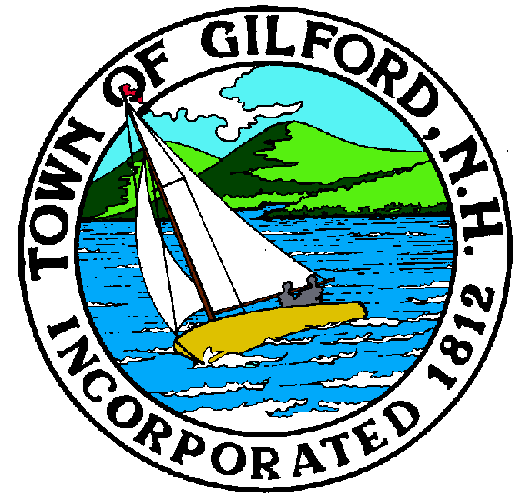

GILFORD CONSERVATION COMMISSION

TUESDAY

JUNE 21, 2022

GILFORD TOWN HALL

47 CHERRY VALLEY ROAD

GILFORD, NH 03249
7:00 P.M.

You may attend the meeting in person at the Town Hall, or join the meeting remotely with a computer, tablet or smartphone by using the following link:
https://global.gotomeeting.com/join/859301829
You can also dial in using your phone.
United States: +1 (646) 749-3122
Access Code: 859-301-829
REMOTE PARTICIPATION IS PROVIDED AS A COURTESY. SHOULD THERE BE TECHNICAL DIFFICULTIES WITH THE TOWN’S SYSTEM, THE MEETING/HEARING WILL NOT BE ADJOURNED.

PLEDGE OF ALLEGIANCE

ATTENDANCE:
a) Call Meeting to Order b) Establish a Quorum c) Approval of Agenda

APPLICATIONS:
Standard
- Cote Family Revocable Trust, 29 Swain Road on Tax Map & Lot #209-073.000 for a 3-lot subdivision residential driveway.
Report out only
- R&S Hickey Family Trust, 44 Varney Point Road Left on Tax Map & Lot #223-482.000 to repair in-kind crib supported dock & boathouse.
- John Spranger, 27 Mark Island on Tax Map & Lot #219-010.000 to install a seasonal boat lift.
- Richard Tilton, 19 Lockes Island on Tax Map & Lot #243-012.000 to repair breakwater due to ice damage.
- DAE Aviation Enterprises Corporation, 61 Recycle Way on Tax Map & Lot #215-026.100 to replace failed culvert.
- Kenneth & Grace Solinsky, 103 Shore Road on Tax Map & Lot #221-048.000 to extend 12” culvert by 30’ to install the extension of pipe and grade between existing yards.

NON-PUBLIC: (If Needed) Non-public Session Per RSA 91-A:3 II (d) Consideration of the acquisition, sale, or lease of real or personal property which, if discussed in public, would likely benefit a party or parties whose interests are adverse to those of the general community.

OTHER BUSINESS:
- Budget
- Weeks Event Report, Invoices for Department of Public Works, Weeks Signage, Event comments
- Weldon – Trail Blaze Signs
- Kiosk Construction & Signage
- Belknap & Carson Field Inspection Reports
6. Other

CORRESPONDENCE / WORKSHOPS:

MINUTES:

ADJOURNMENT:

