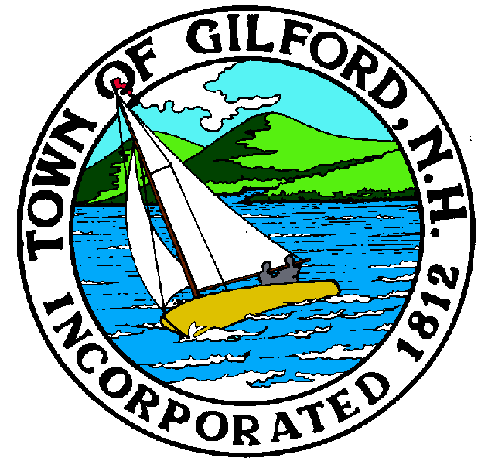
GILFORD CONSERVATION COMMISSION

TUESDAY

JULY 18, 2023

GILFORD TOWN HALL

47 CHERRY VALLEY ROAD

GILFORD, NH 03249
7:00 P.M.

You may attend the meeting in person at the Town Hall, or join the meeting remotely with a computer, tablet or smartphone by using the following link:
https://global.gotomeeting.com/join/859301829
You can also dial in using your phone.
United States: +1 (646) 749-3122
Access Code: 859-301-829
REMOTE PARTICIPATION IS PROVIDED AS A COURTESY. SHOULD THERE BE TECHNICAL DIFFICULTIES WITH THE TOWN’S SYSTEM, THE MEETING/HEARING WILL NOT BE ADJOURNED.

PLEDGE OF ALLEGIANCE

ATTENDANCE:
- Call Meeting to Order
- Establish a Quorum
- Approval of Agenda

APPLICATIONS:

- Wetlands Permit-By-Notification, Wetlands Bureau application for Barbara Aichinger at 558 Edgewater Drive on Tax Map & Lot # 221-007.001.

- Wetlands Permit Application, Standard Dredge and Fill application for Greg Fillmore at 413 Weirs Road on Tax Map & Lot # 216-002.000.

- Shoreland Permit Application for Harold Christensen Realty Trust (Attn: Kari Anderson) at 5 Welch Island on Tax Map & Lot # 250-026.000.

- Wetlands Permit Application, Standard Dredge and Fill for Jeremy Martin at 43 Lockes Hill Road on Tax Map & Lot # 242-376.000.

NON-PUBLIC: (If Needed) Non-public Session Per RSA 91-A:3 II (d) Consideration of the acquisition, sale, or lease of real or personal property which, if discussed in public, would likely benefit a party or parties whose interests are adverse to those of the general community.

OTHER BUSINESS:

- Entrance repair on Weeks Conservation area and Smart woods
- Other

CORRESPONDENCE / WORKSHOPS:

MINUTES: June 20, 2023

ADJOURNMENT:

