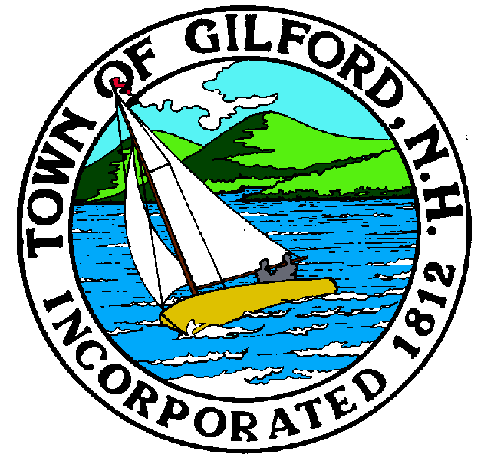

GILFORD CONSERVATION COMMISSION

TUESDAY

JULY 19, 2022

GILFORD TOWN HALL

47 CHERRY VALLEY ROAD

GILFORD, NH 03249
7:00 P.M.

PLEDGE OF ALLEGIANCE

ATTENDANCE:
a) Call Meeting to Order b) Establish a Quorum c) Approval of Agenda

APPLICATIONS:

Report out only
- Big Pier Repairs – Lake Shore Park, 2600 Lake Shore Rd, Tax Map & Lot # 252-016.000

NON-PUBLIC: (If Needed) Non-public Session Per RSA 91-A:3 II (d) Consideration of the acquisition, sale, or lease of real or personal property which, if discussed in public, would likely benefit a party or parties whose interests are adverse to those of the general community.

OTHER BUSINESS:

- Belknap Range Trail to be named.
- Belknap Range Trail – kiosk, other
- Site Review
- Other

CORRESPONDENCE / WORKSHOPS:

MINUTES:

ADJOURNMENT:

