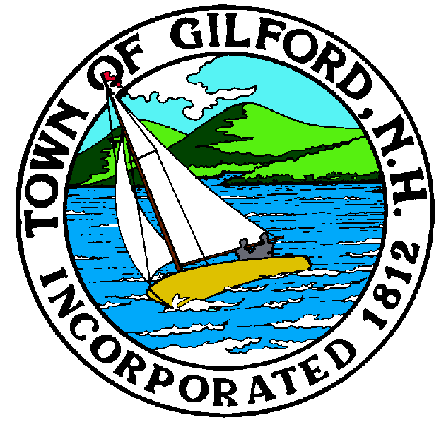
GILFOR

THE GILFORD

CONSERVATION COMMISSION
CANCELLED
THE MEETING

SCHEDULED
FOR
Tuesday,

July 6, 2021

