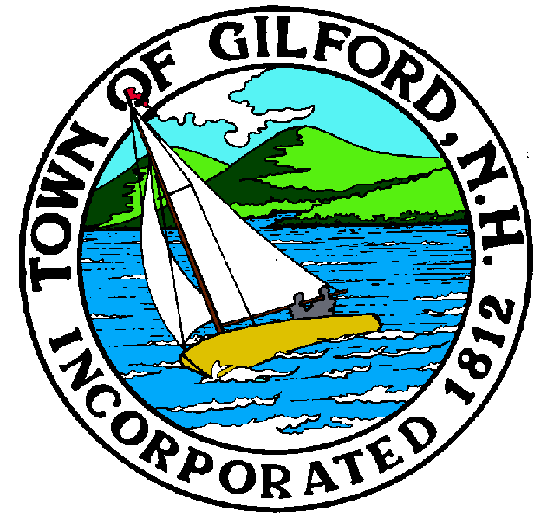
GILFORD CONSERVATION COMMISSION

TUESDAY

AUGUST 15, 2023

GILFORD TOWN HALL

47 CHERRY VALLEY ROAD

GILFORD, NH 03249
7:00 P.M.

You may attend the meeting in person at the Town Hall, or join the meeting remotely with a computer, tablet or smartphone by using the following link:
https://global.gotomeeting.com/join/859301829
You can also dial in using your phone.
United States: +1 (646) 749-3122
Access Code: 859-301-829
REMOTE PARTICIPATION IS PROVIDED AS A COURTESY. SHOULD THERE BE TECHNICAL DIFFICULTIES WITH THE TOWN’S SYSTEM, THE MEETING/HEARING WILL NOT BE ADJOURNED.

PLEDGE OF ALLEGIANCE

ATTENDANCE:
- Call Meeting to Order
- Establish a Quorum
- Approval of Agenda

APPLICATIONS:
- Standard Dredge & Fill, Wetlands Permit Application for Callahan Family revocable Trust at 85 Dockham Shore Rd., on Tax Map & Lot #223-053.000. Reconstruct an existing boathouse and associated support structures and dockage. Boathouse and dockage footprint not to be altered, roof elevation of boathouse to be altered. Request after he fact approval for seasonal watercraft lifts.

- The Paddocks at Stone Brook Hills on 166 Glidden Rd., Tax Map &Lot # 271-008.001. Revised resubmitted supplemental material that the Commission already acted on for this application.

- Alteration of Terrain (AoT) Bureau Permit Application for the Laconia Municipal Airport west side access. Review plans for wetland soil locations.

NON-PUBLIC: (If Needed) Non-public Session Per RSA 91-A:3 II (d) Consideration of the acquisition, sale, or lease of real or personal property which, if discussed in public, would likely benefit a party or parties whose interests are adverse to those of the general community.

OTHER BUSINESS:
- Smith Cove Milfoil removal – Gary report
- Weeks – parking lot roadway repair
- Campbell Conservation Easement – Doug report
- Site Review
- Merrill Fay request with regard to project list
- Other

CORRESPONDENCE / WORKSHOPS:

MINUTES: August 1, 2023

ADJOURNMENT:

