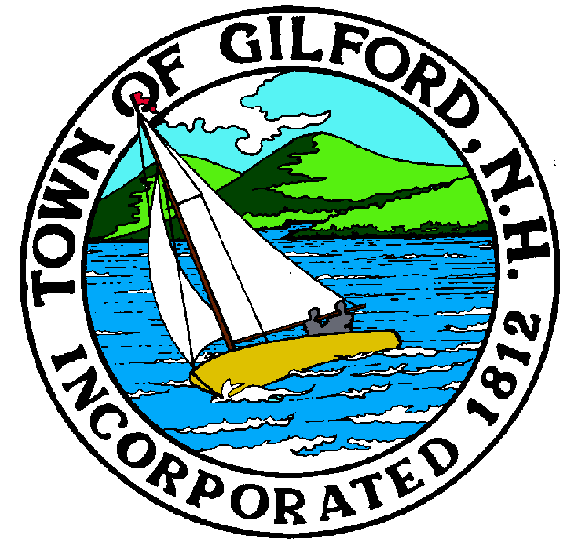

GILFORD CONSERVATION COMMISSION

TUESDAY

AUGUST 16, 2022

GILFORD TOWN HALL

47 CHERRY VALLEY ROAD

GILFORD, NH 03249
7:00 P.M.

PLEDGE OF ALLEGIANCE

ATTENDANCE:
a) Call Meeting to Order b) Establish a Quorum c) Approval of Agenda

APPLICATIONS:

NON-PUBLIC: (If Needed) Non-public Session Per RSA 91-A:3 II (d) Consideration of the acquisition, sale, or lease of real or personal property which, if discussed in public, would likely benefit a party or parties whose interests are adverse to those of the general community.

OTHER BUSINESS:

- Weeks parcel suggested change in trail name from Ledge to Ledges Trail, map printing cost, kiosk construction cost
- Site Review
- Other

CORRESPONDENCE / WORKSHOPS:

MINUTES:

ADJOURNMENT:

