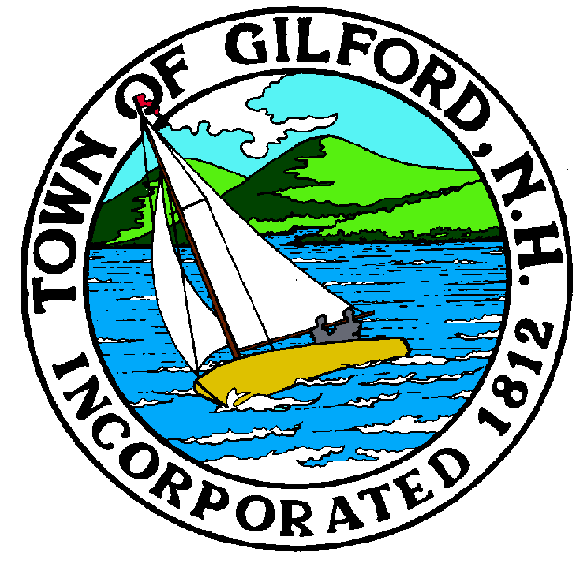
GILFORD CONSERVATION COMMISSION

TUESDAY

SEPTEMBER 19, 2023

GILFORD TOWN HALL

47 CHERRY VALLEY ROAD

GILFORD, NH 03249
7:00 P.M.

You may attend the meeting in person at the Town Hall, or join the meeting remotely with a computer, tablet or smartphone by using the following link:
https://global.gotomeeting.com/join/859301829
You can also dial in using your phone.
United States: +1 (646) 749-3122
Access Code: 859-301-829
REMOTE PARTICIPATION IS PROVIDED AS A COURTESY. SHOULD THERE BE TECHNICAL DIFFICULTIES WITH THE TOWN’S SYSTEM, THE MEETING/HEARING WILL NOT BE ADJOURNED.

PLEDGE OF ALLEGIANCE

ATTENDANCE:
- Call Meeting to Order
- Establish a Quorum
- Approval of Agenda

APPLICATIONS:
1. Standard Dredge and Fill, Wetlands Permit Application for The Preserve at Stone Brook Hills, LLC at 123 Glidden Road on Tax Map & Lot #271-007.000. The project proposes to impact a total of 25,534 sq. ft. of jurisdictional areas including filing 15,039 sq. ft. of forested wetlands, 6,96+0 sq. ft. of emergent, maintained grass areas, 554 sf of stream impacts and will also dredge a portion of an existing fire and agricultural pond for 2,9841 sq. ft. of area. The total area of jurisdictional impacts is 25, 534 sq. ft. The total linear ft. of Tier 1 intermittent stream impacts is 213 ft. Application was tabled from the September 5, 2023 meeting.

2. Standard Dredge and Fill, Wetlands Permit Application for Michael Colizzi at 1 Lockes Island on Tax Map & Lot # 243-033.000. The project proposal is to stabilize the bank where there is a barge landing and access.

NON-PUBLIC: (If Needed) Non-public Session Per RSA 91-A:3 II (d) Consideration of the acquisition, sale, or lease of real or personal property which, if discussed in public, would likely benefit a party or parties whose interests are adverse to those of the general community.

OTHER BUSINESS:
- Smith Cove Milfoil hand-pulling receipts
- Site Review
- 2024 - Budget
- Other

CORRESPONDENCE / WORKSHOPS:

MINUTES: September 5, 2023

ADJOURNMENT:

