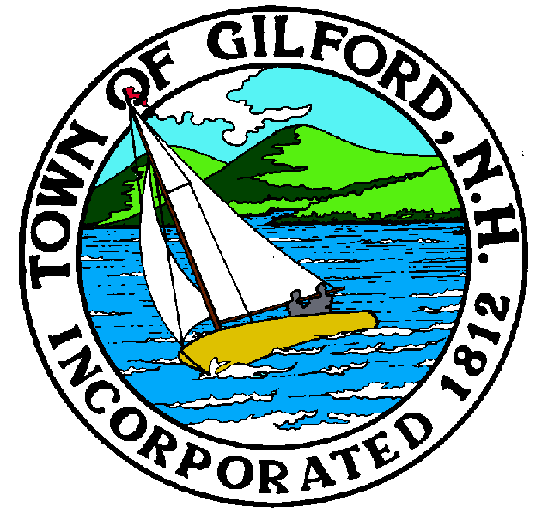

GILFORD CONSERVATION COMMISSION

TUESDAY

SEPTEMBER 6, 2022

GILFORD TOWN HALL

47 CHERRY VALLEY ROAD

GILFORD, NH 03249
7:00 P.M.

PLEDGE OF ALLEGIANCE

ATTENDANCE:
a) Call Meeting to Order b) Establish a Quorum c) Approval of Agenda

APPLICATIONS: Two PBN's to report

PRESENTATIONS:

NON-PUBLIC: (If Needed) Non-public Session Per RSA 91-A:3 II (d) Consideration of the acquisition, sale, or lease of real or personal property which, if discussed in public, would likely benefit a party or parties whose interests are adverse to those of the general community.

OTHER BUSINESS:
1. Smith Cove invoices – Budget total $17,000.
2. Lake Winnipesaukee Assoc. (Pat Tarpey) invoice $2,500 for water quality monitoring
3. 2023 Conservation Budget overview - Lee
4. Weeks Parcel - update
5. Site Review - airport question
6. Other

CORRESPONDENCE / WORKSHOPS:

MINUTES:

ADJOURNMENT:

