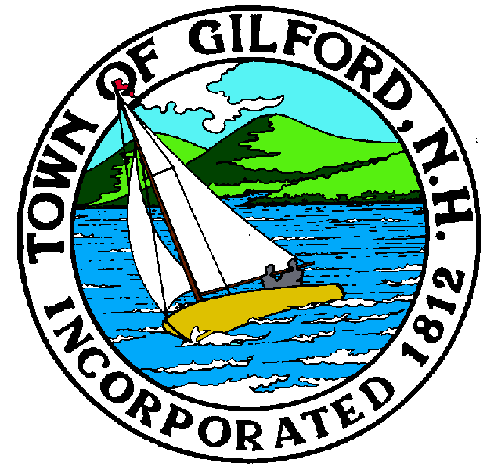
Gilford Conservation Commission
Notice of Public Hearing
Acquisition of Land Per RSA 36-A:5
Tuesday,
December 20, 2022
Gilford Town Hall

Conference Room A

47 Cherry Valley Road
Gilford, NH 03249
7:00 P.M.

You may attend the meeting in person at the Town Hall, or join the meeting remotely with a computer, tablet or smartphone by using the following link:
https://global.gotomeeting.com/join/859301829
You can also dial in using your phone.
United States: +1 (646) 749-3122
Access Code: 859-301-829
REMOTE PARTICIPATION IS PROVIDED AS A COURTESY. SHOULD THERE BE TECHNICAL DIFFICULTIES WITH THE TOWN’S SYSTEM, THE MEETING/HEARING WILL NOT BE ADJOURNED.

The Gilford Conservation Commission will hold a Public Hearing on Tuesday, December 20, 2022 at 7:00 PM in Conference Room A of the Gilford Town Hall, for the purchase of a Conservation Easement of 43 Acres, more or less, situated at 566 Gilford Avenue, being the property identified in the Town of Gilford Tax Records as Tax Map & Lot # 211-006.000 and in the Warranty Deed dated December 31, 1997, recorded with the Belknap County Registry of Deeds in Book 1449 & Page 0457. The amount of money to be used from the Town of Gilford Conservation Land Fund is $120,000 plus expenditures and closing costs for the purchase of the Conservation Easement to this property. No funds will be drawn from general revenues.

