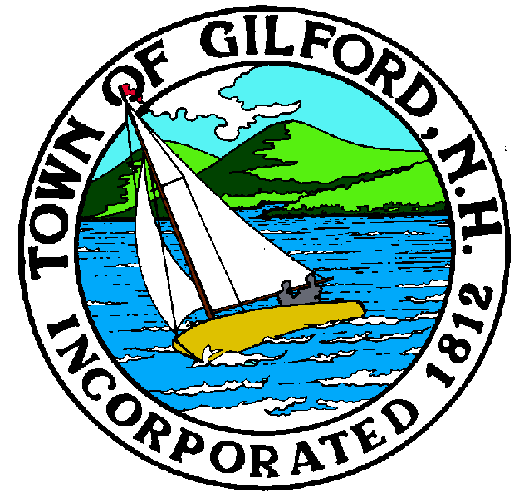
Gilford Planning Board
Agenda
Monday, November 7, 2022
Gilford Town Hall

Conference Room A

47 Cherry Valley Road
Gilford, NH 03249
7:00 P.M.

The Gilford Planning Board will hold a Public Meeting on Monday, November 7, 2022 at 7:00 p.m. in Conference Room A in the Gilford Town Hall, to consider the items below. Anyone interested is invited to attend.

1. Possible 2023 Zoning Ordinance Amendments
– Short Term Rentals
– Other Amendments

2. Discussion Items
– 2023 Land Use Board Meeting Calendar and Schedule

3. Minutes

4. Adjournment

If you have questions or wish to obtain further information, please contact the Town of Gilford Department of Planning and Land Use at (603) 527-4727 or stop by the DPLU office at the Gilford Town Hall, 47 Cherry Valley Road, Gilford, New Hampshire 03249.

