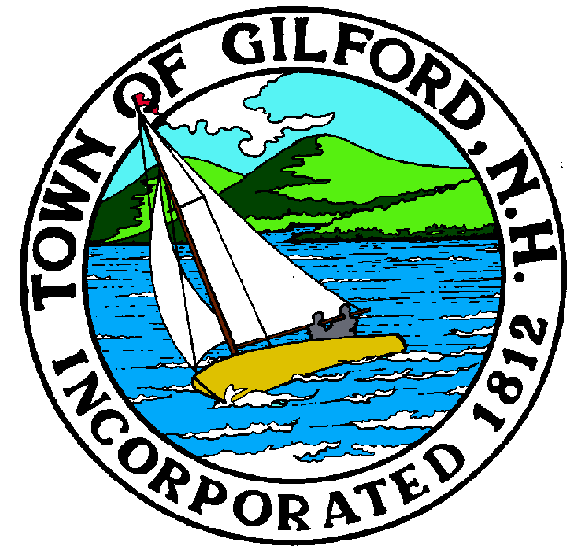
Gilford Planning Board
Agenda
Monday, December 6, 2021
Gilford Town Hall

Conference Room A

47 Cherry Valley Road
Gilford, NH 03249
7:00 P.M.

You may attend the meeting in person at the Town Hall, or join the meeting remotely with a computer, tablet, or smartphone using the following link: https://global.gotomeeting.com/join/206981941,
or dial in using a phone at: (571) 317-3112 with Access Code: 206-981-941.

REMOTE PARTICIPATION IS PROVIDED AS A COURTESY. SHOULD THERE BE TECHNICAL DIFFICULTIES WITH THE TOWN’S SYSTEM, THE MEETING/HEARING WILL NOT BE ADJOURNED.

The Gilford Planning Board will hold a Public Hearing on Monday, December 6, 2021 at 7:00 p.m. in Conference Room A in the Gilford Town Hall, to consider the applications below. Once an application is accepted as complete, the public hearing will follow. Anyone interested is invited to attend.

1. Public Hearings

1.1 Alrig USA – Applicant proposes to remove the existing buildings and uses, and construct a new two-unit building with Unit 1 being a take-out restaurant and Unit 2 being a Starbucks restaurant with drive-through window, on property located at 1429 Lake Shore Road on Tax Map & Lot #201-023.000 in the Commercial (C) Zone, Community Character Protection District, and Aquifer Protection District. Site Plan Review. Application #2021000717. Application was tabled from the November 15, 2021 meeting.

2. Action on Above

3. Discussion Items
● Possible 2022 Zoning Ordinance Amendments

4. Minutes

5. Adjournment

If you have questions or wish to obtain further information, please contact the Town of Gilford Department of Planning and Land Use at (603) 527-4727 or stop by the DPLU office at the Gilford Town Hall, 47 Cherry Valley Road, Gilford, New Hampshire 03249.

