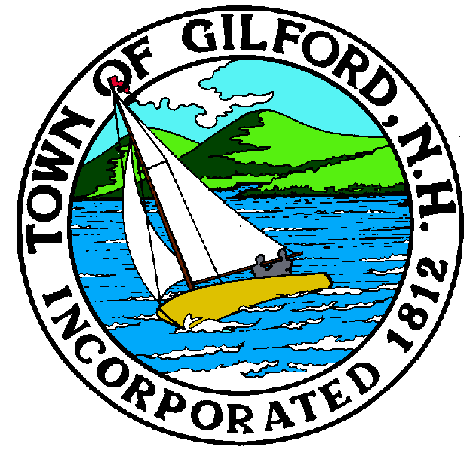
Gilford Planning Board
Agenda
Monday, April 4, 2022
Gilford Town Hall

Conference Room A

47 Cherry Valley Road
Gilford, NH 03249
7:00 P.M.

You may attend the meeting in person at the Town Hall, or join the meeting remotely with a computer, tablet, or smartphone using the following link: https://global.gotomeeting.com/join/206981941,
or dial in using a phone at: (571) 317-3112 with Access Code: 206-981-941.

REMOTE PARTICIPATION IS PROVIDED AS A COURTESY. SHOULD THERE BE TECHNICAL DIFFICULTIES WITH THE TOWN’S SYSTEM, THE MEETING/HEARING WILL NOT BE ADJOURNED.

The Gilford Planning Board will hold a Public Meeting on Monday, April 4, 2022 at 7:00 p.m. in Conference Room A in the Gilford Town Hall, to consider the items below. Anyone interested is invited to attend.

1. Possible 2023 Zoning Ordinance Amendments
– Short Term Rentals

2. Discussion Items
– Possible Site Changes - Laconia Municipal Airport

3. Minutes

4. Adjournment

If you have questions or wish to obtain further information, please contact the Town of Gilford Department of Planning and Land Use at (603) 527-4727 or stop by the DPLU office at the Gilford Town Hall, 47 Cherry Valley Road, Gilford, New Hampshire 03249.

