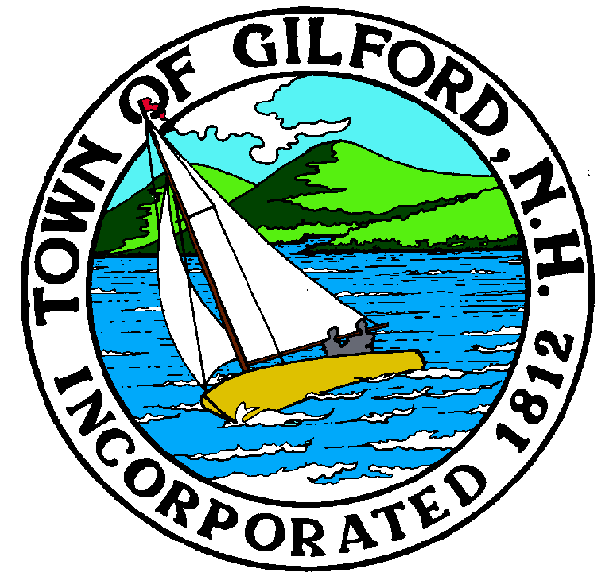
Gilford Planning Board
Notice of Public Hearing
Monday
February 13, 2023
Gilford Town Hall
Conference Room A

47 Cherry Valley Road
Gilford, NH 03249
7:00 P.M.

The Gilford Planning Board will hold a Public Hearing on February 13, 2023 at 7:00 p.m. in Conference Room A in the Gilford Town Hall, to consider the applications below. Once an application is accepted as complete, the public hearing will follow. Anyone interested is invited to attend.

1. Public Hearings

1.1 Meadowbrook Amphitheatre Holdings LLC – Applicants are proposing to (1) construct a 3,200 sq. ft. Commissary Building to replace multiple existing vendor structures and, (2) construct a 1,720 sq. ft. vehicle entry kiosk on Music Row. The property is located at 66 and 72 Meadowbrook Lane on Tax Map & Lot #224-008.000 & #224-009.000 in the Resort Commercial (RC) Zone, Airport District, Community Character Protection District, and Aquifer Protection District. Amended Site Plan Review. Application #2023000023.

1.2 Energy North, Inc. – Applicants are proposing to remove the existing gas station and convenience store and construct a new retail motor fuel outlet including a 6,200 sq. ft. convenience store with coffee/donut shop drive-thru & pizza shop, and a retail fuel canopy with six (6) fuel islands, 12 fueling positions, and 27 striped parking spaces. The project includes excavation and filling within a wetland buffer which requires approval of a conditional use permit. The property is located at 55 & 63 Gilford East Drive on Tax Map Lot #213-025.000 & #213-026.000 in the Commercial (C) Zone, Airport District, Aquifer Protection District, and Community Character Protection District. Site Plan Review & Conditional Use Permit. Application #2023000024

2. Action on Above

3. Other Business

4. Minutes

5. Adjournment

If you have questions or wish to obtain further information, please contact the Town of Gilford Department of Planning and Land Use at (603) 527-4727 or stop by the DPLU office at the Gilford Town Hall, 47 Cherry Valley Road, Gilford, New Hampshire 03249.

