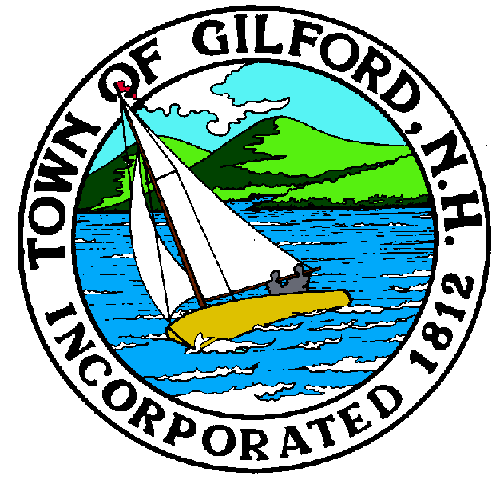
Gilford Planning Board
Notice of Public Hearing
Monday
November 15, 2021
Gilford Town Hall
Conference Room A

47 Cherry Valley Road
Gilford, NH 03249
7:00 P.M.

You may join the meeting with a computer, tablet, or smartphone via GoToMeeting at https://global.gotomeeting.com/join/206981941,
or dial in using a Phone at (571) 317-3112 with Access Code 206-981-941.

REMOTE PARTICIPATION IS PROVIDED AS A COURTESY. SHOULD THERE BE TECHNICAL DIFFICULTIES WITH THE TOWN’S SYSTEM, THE MEETING/HEARING WILL NOT BE ADJOURNED.

The Gilford Planning Board will hold a Public Hearing on Monday, November 15, 2021 at 7:00 p.m. in Conference Room A in the Gilford Town Hall, to consider the applications below. Once an application is accepted as complete, the public hearing will follow. Anyone interested is invited to attend.

1. Public Hearings

1.1 Boston University Rocket Propulsion Group – Applicant proposes to conduct Static Rocket Engine Testing as a Medium Industrial Use pursuant to Sections 4.4.2.a. and 4.7.4 of the Gilford Zoning Ordinance. The proposal includes outdoor testing of rocket engines mounted to portable, temporary test stands on a 54-acre property owned by the Laconia Airport Authority and located at 240 Lily Pond Road on Tax Map & Lot #215-003.100 in the Industrial (I) Zone, Airport District, Prime Wetlands District, and Aquifer Protection District. Site Plan Review. Application #2021000716.

1.2 Alrig USA – Applicant proposes to remove the existing buildings and uses, and construct a new two-unit building with Unit 1 being a take-out restaurant and Unit 2 being a Starbucks restaurant with drive-through window, on property located at 1429 Lake Shore Road on Tax Map & Lot #201-023.000 in the Commercial (C) Zone, Community Character Protection District, and Aquifer Protection District. Site Plan Review. Application #2021000717.

2. Action on Above

3. Other Business

4. Minutes

5. Adjournment

If you have questions or wish to obtain further information, please contact the Town of Gilford Department of Planning and Land Use at (603) 527-4727 or stop by the DPLU office at the Gilford Town Hall, 47 Cherry Valley Road, Gilford, New Hampshire 03249.

