NOTICE – TOWN OF GILFORD, New Hampshire

The Gilford Planning Board will conduct a public hearing to consider changes to the Gilford Zoning Ordinance on Monday, December 18, 2023 at 7:00 p.m. in Conference Room A at the Gilford Town Hall, 47 Cherry Valley Road, Gilford, New Hampshire. Anyone interested is invited to attend. This is the first public hearing for these items.

PROPOSED ZONING ORDINANCE CHANGES

A public hearing will be held to consider the following proposed amendment submitted by Petition:

1. Rezone 700 Cherry Valley Road – This is a proposal to see if the Town of Gilford will vote to amend the official Zoning Map of the Town of Gilford as requested by Nick Tamposi, by changing the zoning of the lot at 700 Cherry Valley Road (Tax Map & Lot #254-072.000) from Limited Residential (LR) to Resort Commercial (RC), which lot contains 2 acres and is located across from the Gunstock Ski Area entrance and adjacent to the former Arlberg Inn property which is already zoned Resort Commercial.

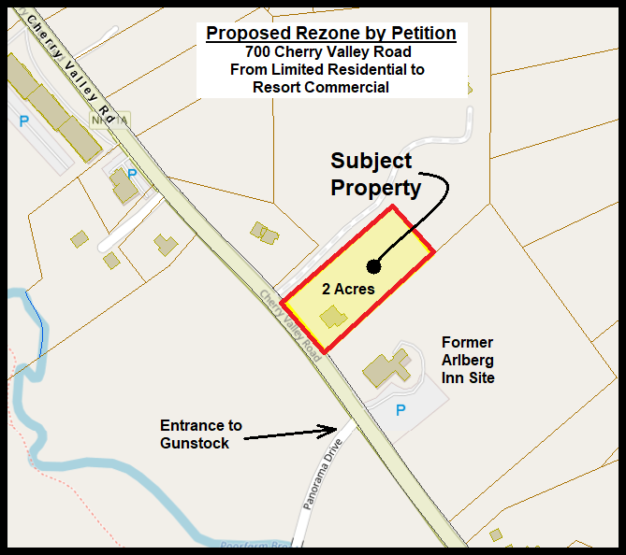

A public hearing will be held to consider the following amendments proposed by the Gilford Planning Board:

2. Amend Reference to Statutes in Short-Term Rental Regulations – This is a proposal to amend Section 22.7.1 to correct a reference to state statutes changing the reference from RSA 676:16 to RSA 676:15 so the section correctly refers to injunctive relief provisions in the RSAs.

3. Update Administration & Enforcement Section – This is a proposal to amend paragraph b. of Section 23.5, Duration of Permit, to change the time period within which a variance must be utilized from one (1) year to two (2) years from the date of approval so the time frame coincides with NH RSA 674:33 I-a.(a).; and to amend Section 23.6, Penalties, by adding the following sentence, “ The penalties set forth herein shall be cumulative and shall be in addition to any other rights and remedies available to the Town at law or equity.”

The exact text of the proposed changes may be inspected at the Town of Gilford website at www.gilfordnh.org, and at the Department of Planning and Land Use (DPLU) and the Town Clerk’s office in the Gilford Town Hall at 47 Cherry Valley Road, Gilford, New Hampshire. DPLU is open Monday through Friday between 8:00 a.m. and 4:30 p.m. The Town Clerk’s office is open from 8:00 a.m. until 4:30 p.m. Monday, Tuesday, Wednesday, and Friday, and until 6:00 p.m. on Thursdays. You may contact the Department of Planning and Land Use by calling (603) 527-4727.

