Gilford police department
Citizen’s police academy
Come see what your Pd is all about

Some of the classes you will take include:
DWI Detection ∙ Courtroom Procedures ∙ Patrol operations
Date: March 14 - May 21, 2023
Every Tuesday from 6:00 pm – 9:00 pm
Location: Gilford Police Department
Emergency operations center

Applications are available on-line or at the police department
Sign up today for an exciting and informative session!
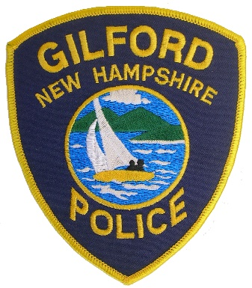
Gilford Police Department
47 Cherry Valley Road
Gilford, NH 03249
603-527-4737
WWW.Gilfordpd.org

