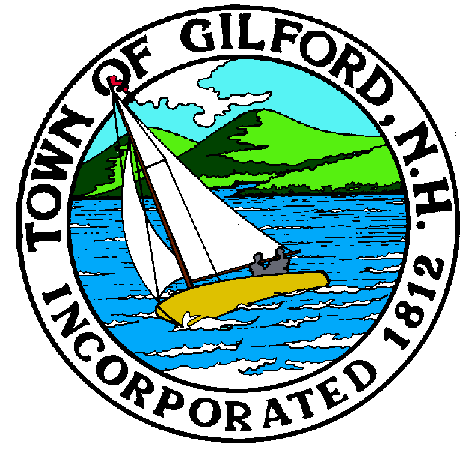

TOWN OF GILFORD, NH
PRESIDENTIAL PRIMARY ELECTION
January 23, 2024

The Presidential Primary Election was held on the above date at the Gilford Church Community Youth Center. On January 16th, 2024 at 1:00 p.m., Moderator, Sandy McGonagle, Assistant Moderator, Larry Routhier, Town Clerk-Tax Collector, Danielle LaFond, Deputy Town Clerk-Tax Collector, Sandra Beland tested the Accuvote machine, prepared a hand tally and reported 100% accuracy. Ballots were counted in Conference Room B at the Gilford Town Hall, put into sets of 25 and resealed for Election Day.

Inspectors of Elections/Ballot Clerks, Travis Cole, Priscilla Bean, Ken Sterner, Reva Tankle, Diane Tinkham, Andrea Stephan, & James Dirubbo were present. The ballots were counted and the moderator signed a receipt for 2,843 Republican ballots and 1,908 Democratic ballots.

The zero tape was run on the Accuvote machine and the ballot boxes were inspected by registered voter Bruce Klinger; he confirmed the boxes were empty. The Moderator instructed the voters to announce their name prior to entering the polling area and instructed the Inspectors to repeat the name back loud enough that the poll watchers may hear them. The Pledge of Allegiance was recited and the polls were declared open at 7a.m.

At the beginning of the election there were 5,845 voters on the checklist at the start of the polls. There were 117 new voters registered during the day and 999 voters returned to undeclared status. The absentee ballot process was started at 9:00 a.m. There were 3,233 ballots cast including absentee ballots; there were 2,585 Republican ballots cast and 649 Democratic ballots cast).There was 54% voter turnout. The Moderator announced the polls closed at 7:00 p.m.

The tally was done by the Moderator, Town Clerk-Tax Collector, Board of Selectmen, Deputy Town Clerk-Tax Collector and Inspectors of Elections. The official results were read by the Moderator with the following results:

 |  | Bill Pearce Kennedy |  | 46
REPUBLICAN BALLOT FOR:  PRESIDENT OF THE UNITED STATES:  ROBERT S. CARNEY JR. 0  JOHN ANTHONY CASTRO 0  CHRIS CHRISTIE 18  RON DESANTIS 38  NIKKI HALEY 1217  ASA HUTCHINSON 0  PETER JEDICK 0  PERRY JOHNSON 0  DONALD KJORNES 0  MARY MAXWELL 0  GLENN J MCPETERS 0  SCOTT PETERSON MERRELL 0  DARIUS L MITCHELL 0  MIKE PENCE 3  VIVEK RAMASWAMY 9  TIM SCOTT 2  HIRSH V SINGH 0  SAMUEL HOWARD SLOAN 0  DAVID STUCKENBURG 0  RACHEL SWIFT 0  DONALD J TRUMP 1272  SCOTT ALAN AYERS 0  RYAN L BINKLEY 2  DOUG BURGUM 1  WRITE INS  CHRIS CHRISTIE 1  RON DESANTIS 2  NIKKI HALEY 2  DONALD J TRUMP 16  DOUG BERGUM 8  MARIANNE WILLIAMSON 1  JOE BIDEN 3  ROBERT J KENNEDY JR 1  DEMOCRATIC BALLOT FOR:  PRESIDENT OF THE UNITED STATES:  TOM KOOS 4  PAUL V LACAVA 1  STAR LOCKE 0  FRANKIE LOZADA 1  STEPHEN P LYONS 0  RAYMOND MICHAEL MOROZ 0  DEREK NADEAU 8  JASON MICHAEL PALMER 1  MANDO PEREZ-SERRATO 0  DEAN PHILLIPS 151  DONALD PICARD 1  PAPERBOY LOVE PRINCE 2  RICHARD RIST 0  VERMIN SUPREME 2  JOHN VAIL 2  MARIANNE WILLIAMSON 22  PRESIDENT R. BODDIE 0  TERRISA BUKOVINAC 1  EBAN CAMBRIDGE 0  GABRIEL CORNEJO 0  MARK STEWART GREENSTEIN 1  WRITE INS:  RON DESANTIS 2  NIKKI HALEY 27  DONALD J TRUMP 17  ROBERT KENNEDY 4  JOSEPH BIDEN 365  CEASE FIRE 4  MEGAN SMITH 2  ALEXANDER CORTEZ 2  JILL STEIN 4  KAMILLA HARRIS 2  CENK UYGUR 4  I would also like to thank the additional Election Officials who helped out with greeting our voters, overseeing the returned to undeclared book and also helped with separating and counting the write ins after the polls closed. They are Susan Allen, Denise Cunningham, Cindy Graham, Susan Greene, Sandra Labonte, Doris MacHaffie, Donna Mooney, Mary Nute, Dorothy Piquado and Wendy Shermet. Also, Colleen and Kassie from Shaw’s in Gilford for providing a great lunch and Fratello’s for donating a wonderful meal for dinner. We appreciate all that contribute to the Town of Gilford!  Respectfully submitted,  Danielle LaFond  Danielle LaFond  Town Clerk-Tax Collector |  | Jackie Cilley |  | 198

