“Recreation Center of New Hampshire”

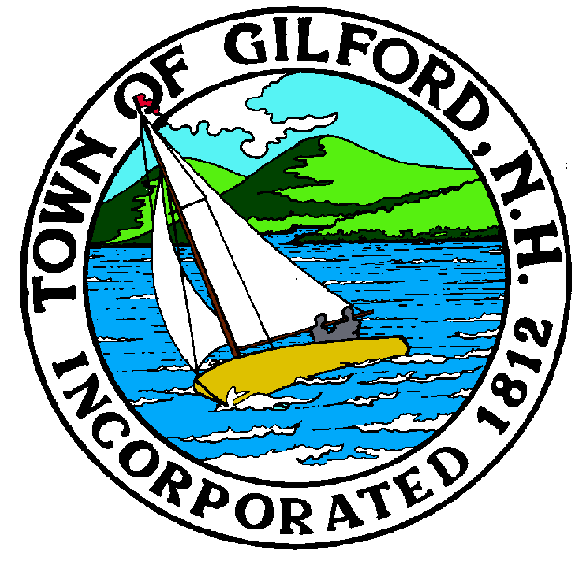

Danielle LaFond
Town Clerk – Tax Collector
Telephone
(603) 527-4713
Fax
(603) 527-4719
E-Mail
dlafond@gilfordnh.org
47 Cherry Valley Rd. Gilford, New Hampshire 03249

Attention Dog Owners of Gilford –

The 2021 Dog Tags are now available. This notice is to remind all dog owners to renew their dogs’ license by April 30, 2021. There is a “grace period” that allows you to come in up to June 1, 2021. After June 1, 2021 a $1.00 a month penalty will be assessed as well as a delinquent list being forwarded to the Police Department for a $30.00 (per dog) civil forfeiture fine. Penalties and fines are charged according to NH State Law.

No documents are needed to renew the dog unless the rabies certificate on file has expired. Dog licenses may be renewed online at www.gilfordnh.org, by mail by sending a check with the appropriate fee and a copy of the rabies (if needed). You may also register by coming to the Town Clerk – Tax Collector’s Office Monday – Friday 8:00 am – 4:30 pm or Thursdays 8:00 am until 6:00 pm. The license fees are as follows:

Puppies | Altered | Unaltered | Senior Citizen (owner 65+ years old)
4 months old - | 7 months old | 7 months old | each owner/keeper limited to 1 discounted license
under 7 months old | & up | & up | any age dog
$6.50 | $6.50 | $9.00 | $2.00

If you no longer have the dog, please call the office at 527-4713 to remove your name from the list.

Sincerely,

Danielle LaFond
Town Clerk – Tax Collector

