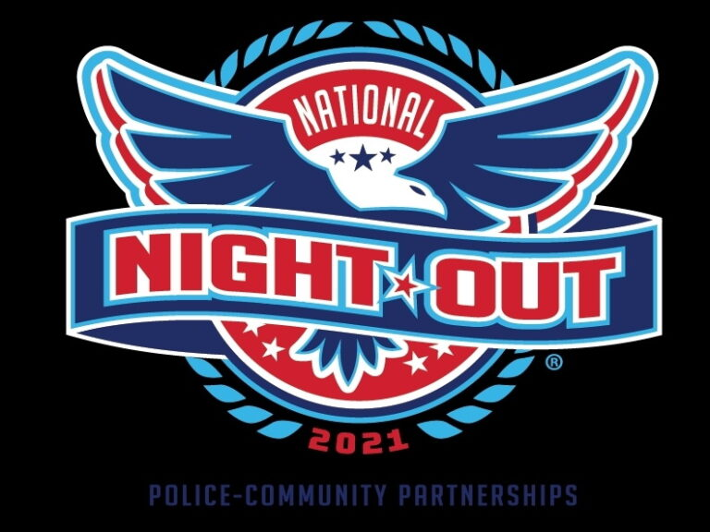
Gilford National Night Out
Tuesday, August 10, 2021 from 6:00pm – 8:00pm at the Gilford Village Field
Please join us for our annual National Night Out community building event to promote police-community partnerships.
We will have members and equipment from several agencies including Gilford Police Department, Gilford Fire Rescue, Belknap Regional Special Operations Group, DHART and Gilford Public Works as well as a K9 Demo with K9 Kai. Community partners will also be on hand to provide information to help benefit community members.
There will be hamburgers and hotdogs to enjoy!

