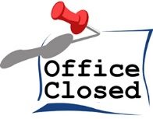
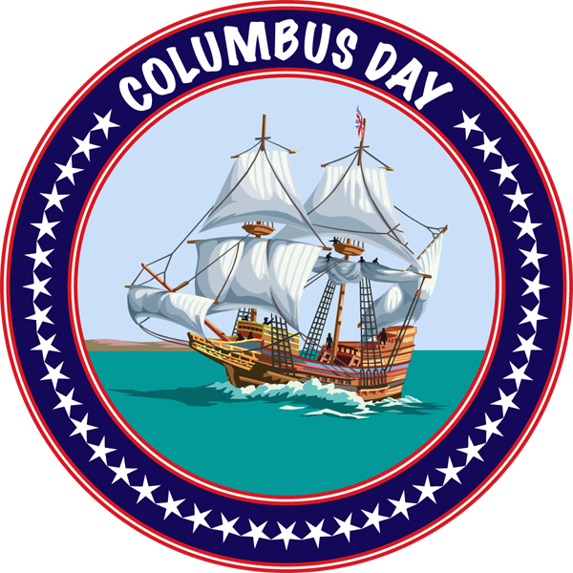

All Town Offices and the Library will be CLOSED on
Monday, October 10, 2022 in
Observance of Columbus Day.

