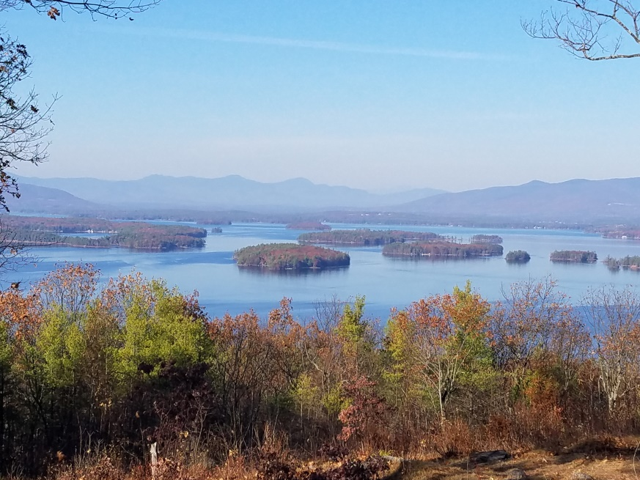
KIMBALL WILDLIFE FOREST COMMITTEE
MEETING Agenda: October 19, 2023; 4:00 PM
Gilford Town Hall Conference Room
- Attendance
- Approval of minutes – September 21, 2023
- Update on Interpretive sign proposal from Jennifer Woodward
-Authorization from Gilford Board of Selectmen (Scott)
- Trail updates:
- Tree cutting for safety access
- BRATT Work Day 9/23 updates (Dan and Karl)
Next meeting: November 16, 2023

