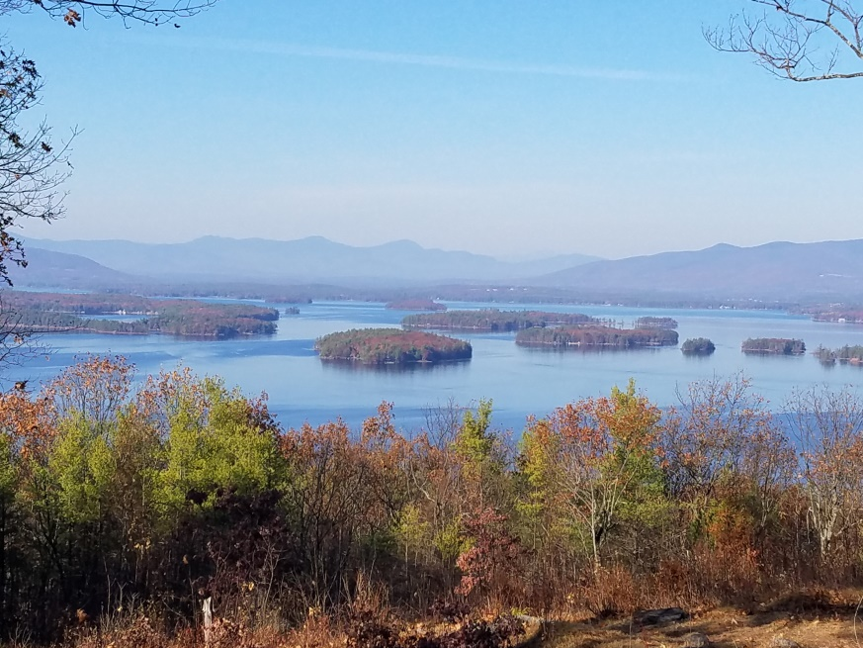
KIMBALL WILDLIFE FOREST COMMITTEE
MEETING Agenda: October 20, 2022; 4:00 PM
Gilford Town Hall Conference Room or Zoom
- Attendance
- Approval of minutes – September 15, 2022
- Old Business:
- Trail Updates-Karl
- Boy Scout Trail Care
- Dog Poop Signs: https://naturegroupie.org/story/manager-tip-what-works-encourage-scooping-poop
4. New Business
- Updates on Town 4 Trail Services project (Erin Amadon) timelines
- Continue Discussion on Proscribed Burn
5. Other
Next meeting: To be determined.

