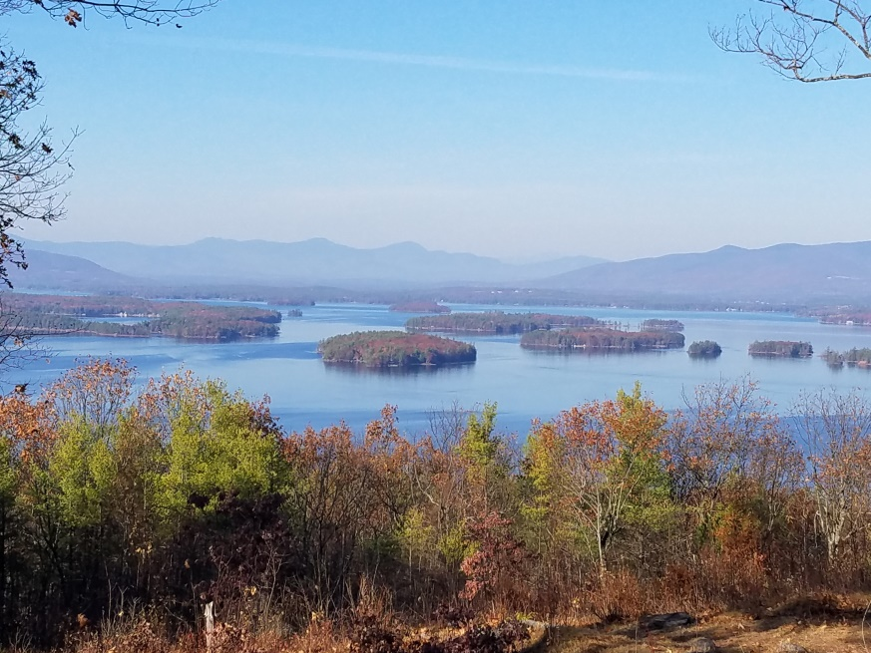
KIMBALL WILDLIFE FOREST COMMITTEE
MEETING Agenda: November 16, 2023; 4:00 PM
Gilford Town Hall Conference Room
- Attendance
- Approval of minutes – October 19, 2023
- Update on Interpretive sign proposal from Jennifer Woodward (See below. Jennifer will zoom in with us.)
- Trail updates:
- BRATT Work Day 9/23 updates (Dan and Karl)
Next meeting: December 21, 2023
From Jennifer:
Below is an update for the committee meeting Thursday. Please let me know if you have any questions.
Budget - Was the budget approved by the Town of Gilford? When the time comes to purchase materials, what is the process?
Panel supports - I reached out to Bob MacPhee and he agreed to take on the task of suggesting a stain color for the panel supports.
Panel content - I sent examples for panel content to the KWF subcommittee and asked for comments. My goal is to have all the content written by mid-January.
Logo/branding - I am working with Yvonne from Kingswood Press & Design Studio (KPDS) on a couple samples for the committee to review and approve. As soon as these are available I will send them to you.
Viewshed Panoramas - Yvonne has worked with drone photographer, John Gisis who is willing to take photographs for the viewshed panorama panels. There is a placeholder in the budget. As an alternative, a high resolution iPhone photograph is acceptable which wouldn't cost anything. Attached are a couple photos I took as an example (low resolution for emailing purposes). Would you please discuss the preference with the KWF Committee? Either way, conversation need to take place about the photographs and labels.
Panel locations - May I please request that the existing signs stay in place until the new ones are installed? They are helpful as reference points for the new panel locations. As I mentioned, I placed short green stakes to mark approximate locations. I may return and use taller wooden stakes as the short ones are difficult to see. Would this be ok?
I wish you and all the committee members a Happy Thanksgiving.
--
Jennifer

