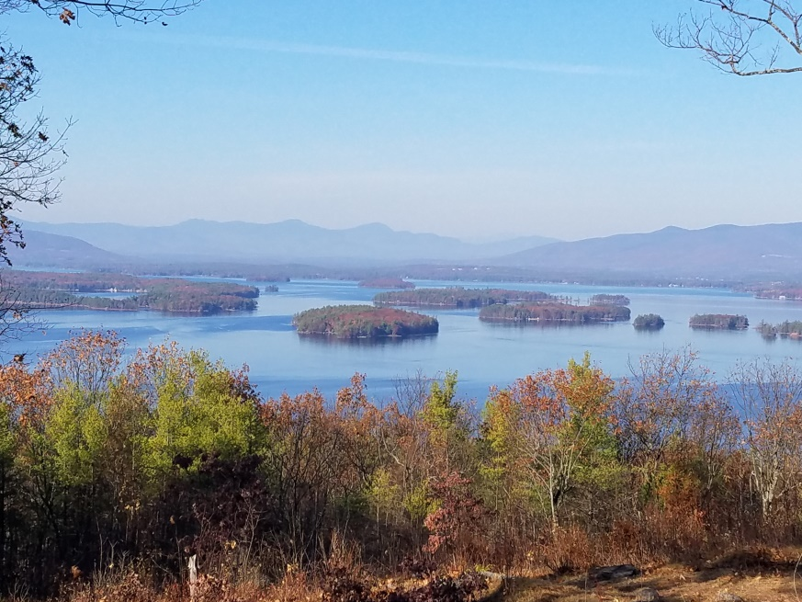
KIMBALL WILDLIFE FOREST COMMITTEE
MEETING Agenda: November 17, 2022; 4:00 PM
Gilford Town Hall Conference Room or Zoom
- Attendance
- Approval of minutes – October 20, 2022
- Old Business:
- Formal vote of approval of electronic vote to recommend to Gilford Board of Selectmen payment of invoice from Tim Nolin in the amount of $660; authorized 10/26/2022.
- Trail Updates-Karl
- Boy Scout Trail Care

4. New Business
- Formation of a committee to revise the Trail Guide
5. Other
Next meeting: To be determined.

