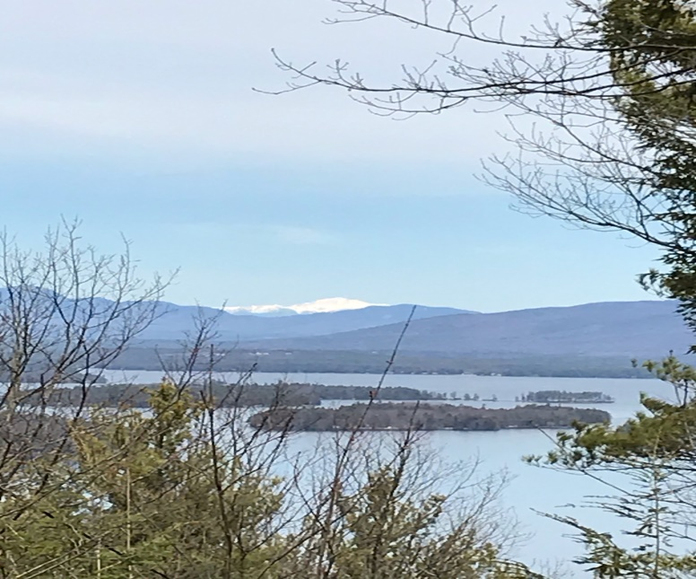
KIMBALL WILDLIFE FOREST COMMITTEE
MEETING Agenda
January 21, 2021 4:00 PM
Virtual Session on Zoom
- Attendance
- Approval of minutes – December 3, 2020
- Work session: Discuss the strengths and areas in need of improvement of the Lockes Hill Trail system
- Castle Update- Scott Dunn

- Old Business:
- Recognition for John Colby
- New Business

- Next Meeting- February 18, 2020

