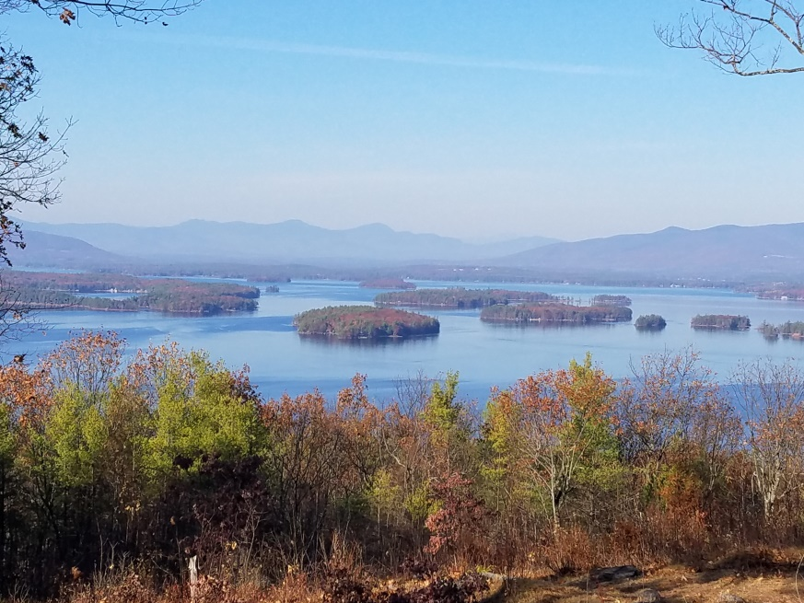
KIMBALL WILDLIFE FOREST COMMITTEE
MEETING Agenda: December 16, 2021 4:00 PM
Gilford Town Hall Conference Room or Zoom
- Attendance
- Approval of minutes – October 21, 2021
- Old Business:
4. New Business
- Update on the December 14 field visit with Rebecca, Matt Tarr, Darrel Tovell, and Tim Nolin regarding potential habitat improvements, including the potential expansion of the oak savanna.
- Discussion of the indigenous history of KWF: Rebecca
5. Other
Next Meeting- January 27, 2022

