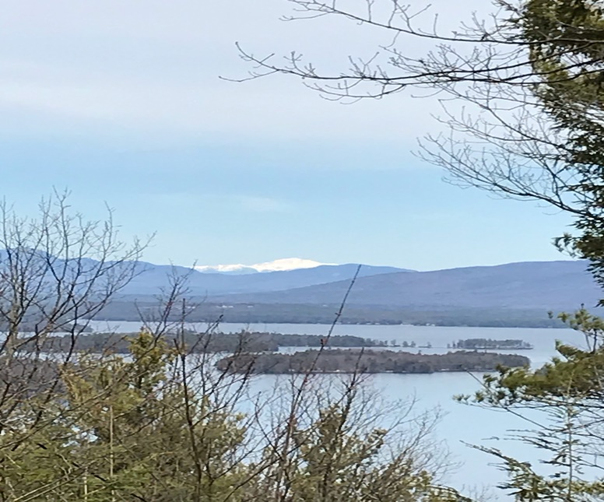
KIMBALL WILDLIFE FOREST COMMITTEE
MEETING Agenda
February 18, 2021 4:00 PM
Virtual Session on Zoom
- Attendance
- Approval of minutes – January 21, 2021
Work session: Review the discussion from the meeting of 1-21-21 and then consider companies who might be able to assist us.

Areas of Improvement noted in our discussion last month:
- trail repair, especially focusing on use of better barriers in order to
discourage the creation of short cuts; creation of signs such
as “Please stay on the trail” or “Be a good hiker”; a note in the brochure reminding hikers to stay on the designated trails.
- access to Carye Trail; signage for the trail should clarify that the trail leads to Rt. 11B and not to the trailhead parking lot on Rt. 11.
- Should we promote use of the Carye Trail if it is not going to be maintained?
- Switchbacks; need advice from a consultant.
- possibility of opening up a trail across the middle of the land; would need help from a consultant for a project like this.
- Would need to check with Tim Nolin on how this might affect forest management plans.
- trail markings; need improvement, repainting, mostly on the Lakeview Trail.
Thoughts from Dan Tinkham:
Sandy et al:
I spoke with Erin Amadon of Town 4 Trail Services, LLC out of Troy, Maine. She recently completed the work at the base of Mt. Major for SPNHF and comes highly recommended. She is not familiar with Lockes Hill or the trails, but does know the area. If we want her to do professional trail work on the Lakeview Trail, she described a typical plan:

- After snowmelt, she would come and walk the trail, hopefully with a group of us, to visualize the problem so she can create an estimate of the scope of services.
- She asked if this work would have to go out to bid and I did not know the answer. Is there a bid requirement for expenditures on the property?
- If so, she will prepare a cost estimate and, if necessary, she can help us prepare bid documents.
- In the meantime, she would like maps for the area including trails and property boundaries and any literature about the trails. I will pull those together and send them off to her.

Other questions:
- Are we willing to relocate trails, if that is deemed the best strategy, or are we restricted to the current trail footprint?
- Much of the big work may require power machinery. Are we okay with bringing small power equipment up the trail (i.e., mini-excavators)? For the switchback portion, that seems feasible and a good idea.
- Between the overlook and the summit the trail is deteriorating badly, but it may be difficult to use power equipment in that area, so we may want to tackle that with more labor intensive efforts. She can walk it with us and advise on that as well.
- She is willing to work with volunteers, but warns that has met with mixed success over the years, depending on who volunteers and what is proposed.
- Are these trails just for walking? One attraction for low grade, sustainable trails is that bikers enjoy using them…

As least we can get started on the discussions…

Thanks.

Dan

- Old Business:
- Recognition for John Colby: Richard and Linda Kyle have provided a picture of a bench which is their first choice in memory of John. I have also advised them that it would likely be May or June before we could get a truck up the Carriage Road to place the bench. Meanwhile we need to decide on what a sign will say in memory of John and get the sign commissioned.

- New Business

- Next Meeting- March 18, 2021

