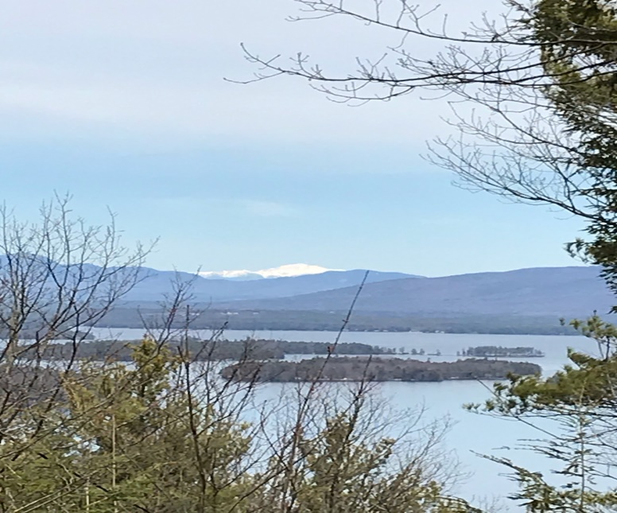
KIMBALL WILDLIFE FOREST COMMITTEE
MEETING Agenda
April 1, 2021 4:00 PM; ZOOM
- Attendance
- Approval of minutes – February 18, 2021
- Old Business:
- Recognition for John Colby: The Kyles have ordered the stone bench and will have it delivered to Gilford after its arrival at their home.
- Decision on a sign recognition: John Colby A true friend and steward of the Kimball Wildlife Forest and Lockes Hill Trails.

- New Business:
- Schedule a meeting with Erin Amadon, Town 4 Trail Services, LLC Troy, Maine to discuss scope of services for switchback trail work on Lakeview Trail.
- Recreational Trails Program Grant: (RTP): recommended for consideration by Dan. Workshop Wednesday, May 5.

- Next Meeting- April 22, 2020

