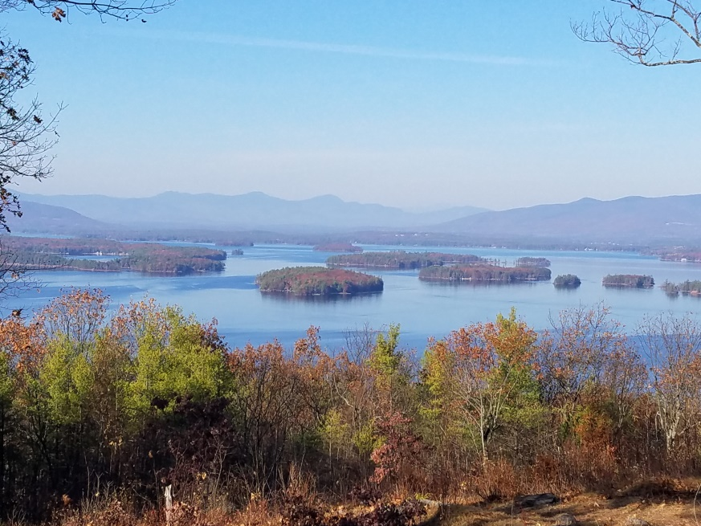
KIMBALL WILDLIFE FOREST COMMITTEE
MEETING Agenda: April 6, 2023; 4:00 PM
Gilford Town Hall Conference Room or Zoom
- Attendance
- Approval of minutes – February 9, 2023
- Action on request to cut trees in Kimball Wildlife Forest
- Continue Work Session: Review and discuss updates to the trail map, demonstration signs and other signs at Lockes Hill Trails.
- Meet with Weldon Bosworth and Nicole Keating from Wayfinder Studio to discuss how they might assist.

Next meeting: May 18, 2023

