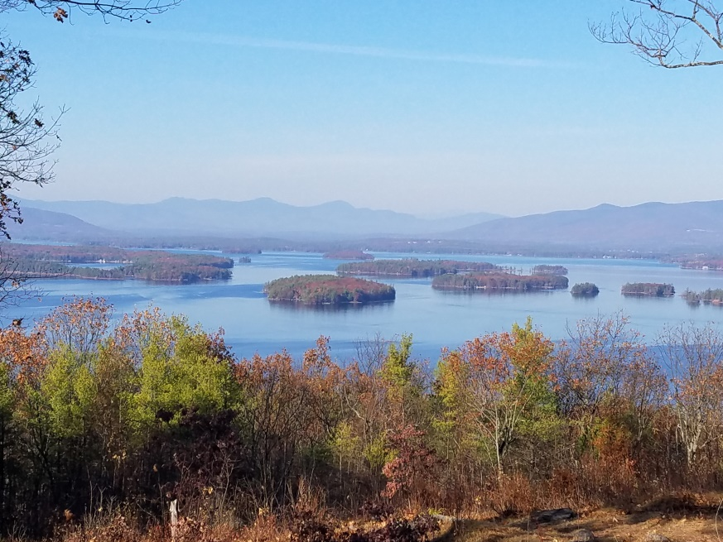
KIMBALL WILDLIFE FOREST COMMITTEE
MEETING Agenda: May 18, 2023; 4:00 PM
Gilford Town Hall Conference Room
- Attendance
- Approval of minutes – April 6, 2023
- Review and discuss updates to the trail map, demonstration signs and other signs at Lockes Hill Trails.
- Review Committee report from meeting with Matt Tarr
- Advice from Jennifer Woodward regarding wording of Interpretive Signs
- Update on Lakeview Trail Work (Erin Amadon): Update from Dan
- Recommended action from Erin Amadon to cut other trees on the Lakeview Trail for safety and hiker access. (Tim Nolin)
- NH Tree Farm Inspection- June 6-7, 2023
- Master Plan Update: Review and Discussion
- Visitation day schedule
Next meeting: June 15, 2023

