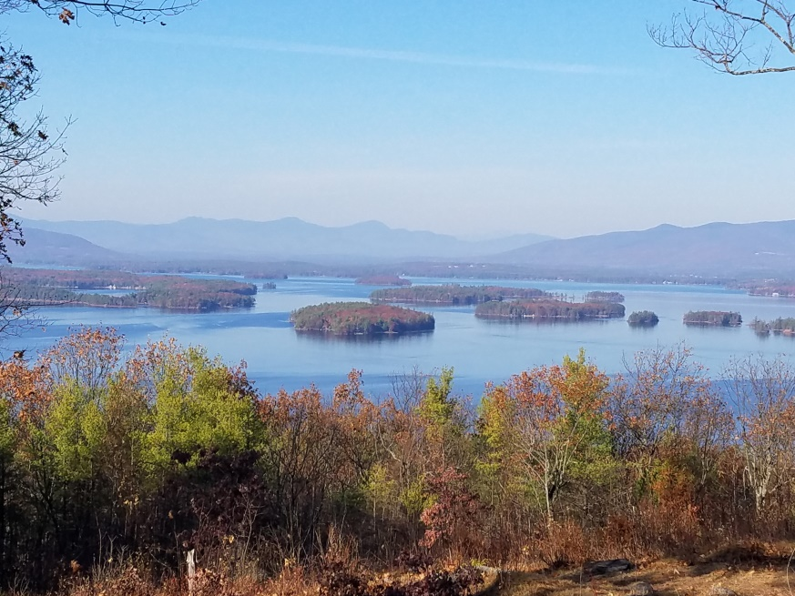
KIMBALL WILDLIFE FOREST COMMITTEE
MEETING Agenda: May 26, 2022; 4:00 PM
Gilford Town Hall Conference Room or Zoom
- Attendance
- Approval of minutes – January 27, 2022
- Old Business:
- Trail Updates-Karl
4. New Business
- Update on potential habitat improvements, including the potential expansion of the oak savana
5. Other
Next Meeting- June 23, 2022; 10:00 AM: Hike – The Indigenous History of Kimball Wildlife Forest; Denise and Paul Pouliot

