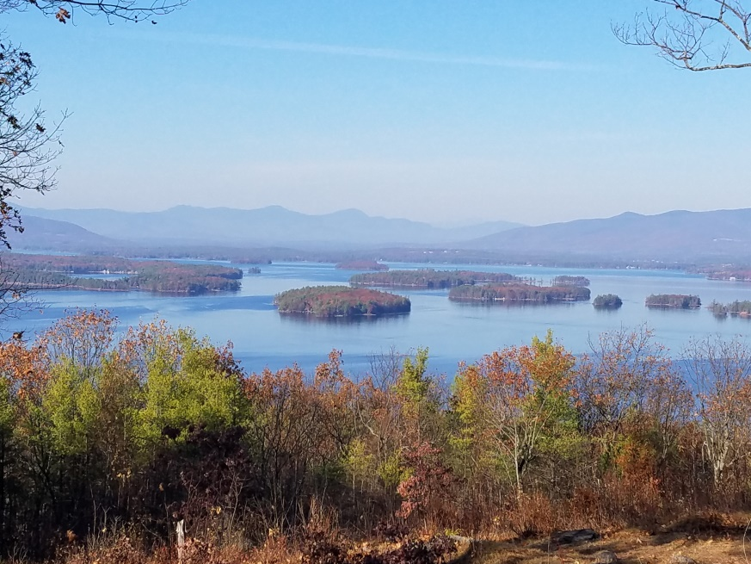
KIMBALL WILDLIFE FOREST COMMITTEE
MEETING Agenda: June 17, 2021 4:00 PM
Gilford Town Hall Conference Room or Zoom
- Attendance: Introduction of Ramona Corson and Karl Gould (Dan)
- Approval of minutes – May 20, 2021
- Old Business:
- Update on recognition of John Colby:
- Update on meeting with Erin Amadon, Town 4 Trail Services, LLC Troy, Maine to discuss scope of services for switchback trail work on Lakeview Trail.
- Updates on Carye Trail improvements: See attached copies of emails from Karl Gould (BRATT) and Beth Gula (New England Forestry Foundation)

4. New Business
Next Meeting- July 15, 2021

