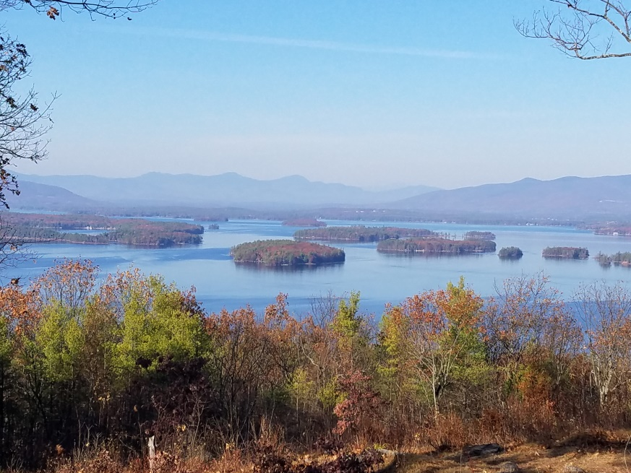
KIMBALL WILDLIFE FOREST COMMITTEE
MEETING Agenda: July 22, 2021 4:00 PM
Gilford Town Hall Conference Room or Zoom
- Attendance
- Approval of minutes – June 17, 2021
- Old Business:
- Set date for recognition of John Colby:
- Review and Discussion of proposal from Erin Amadon, Town 4 Trail Services, LLC Troy, Maine for switchback trail work on Lakeview Trail.
- Updates on Carye Trail improvements: Karl Gould

4. New Business
Next Meeting- August 19, 2021

